|  |
| --- |
| **10.1 Solid Geometry** |

**Learning Objectives**: Students will classify three-dimensional figures according to their properties and use nets and cross sections to analyze three-dimensional figures.

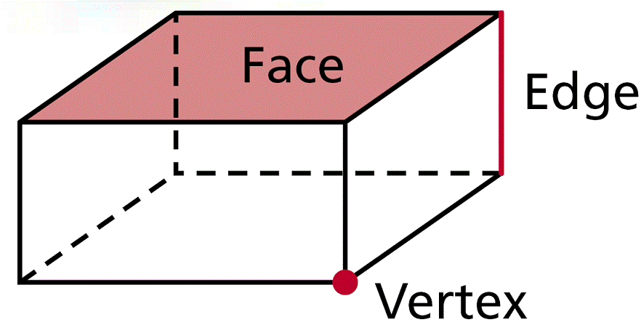

Face –

Edge –

Vertex -

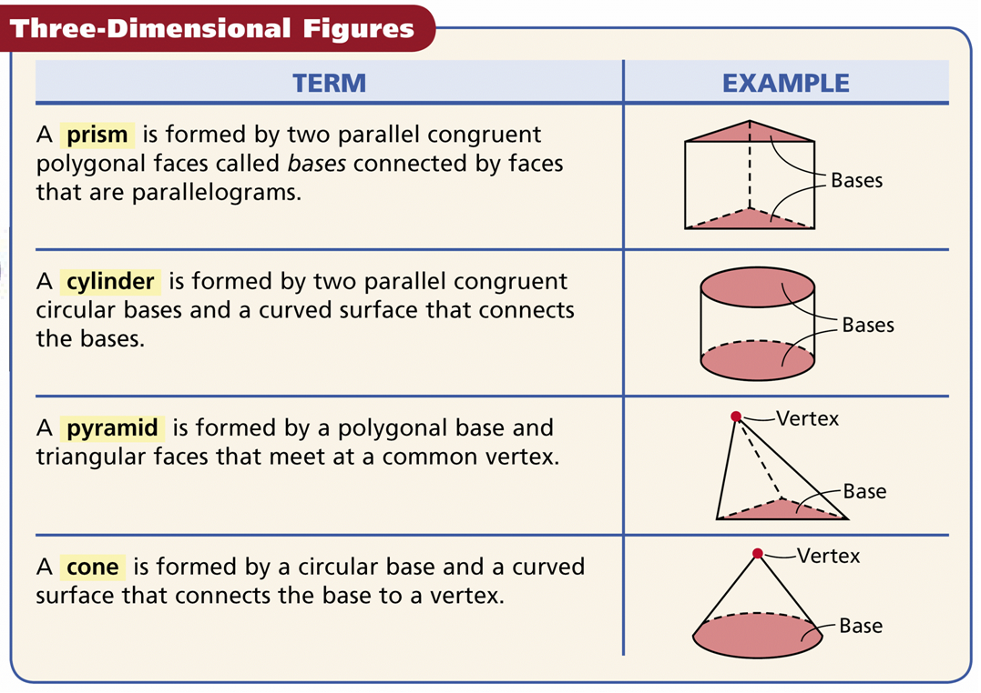

A cube is a prism with six square faces. Draw two ways:

Prisms and pyramids are named for the shape of their .

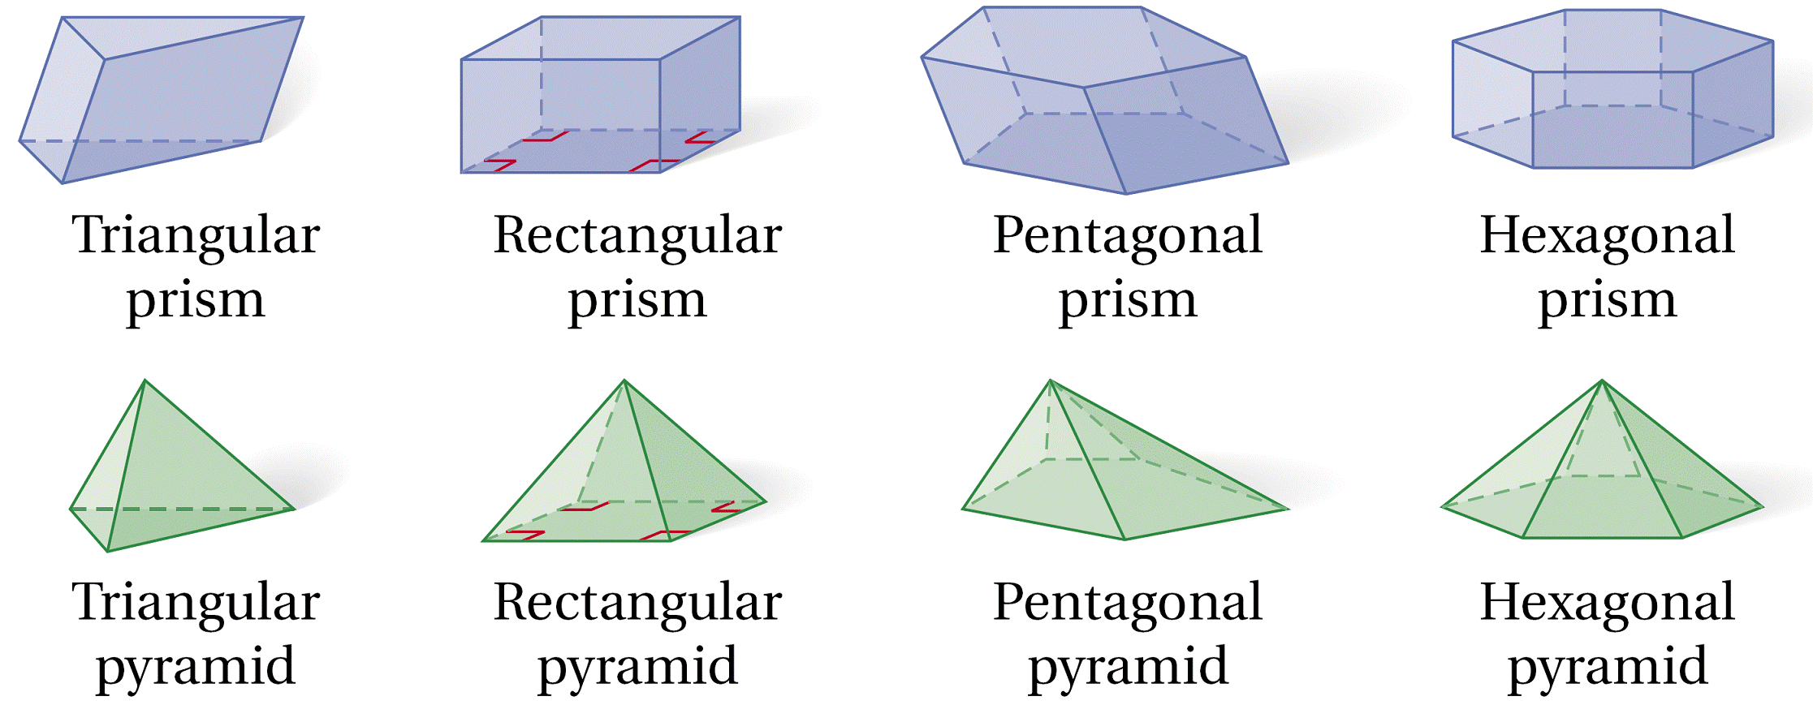

Classify the figure. Give an example of the following: vertices, edges, and bases.

Example 1: Example 2:

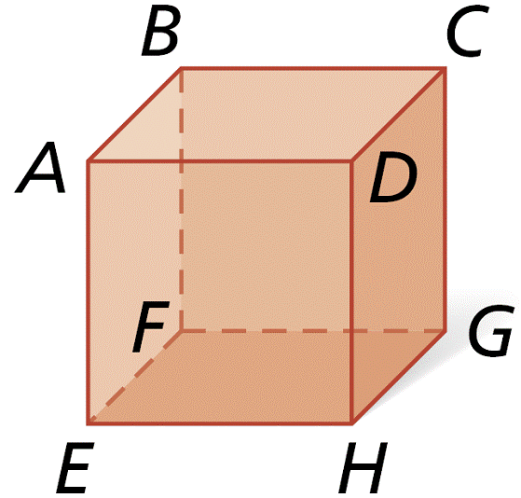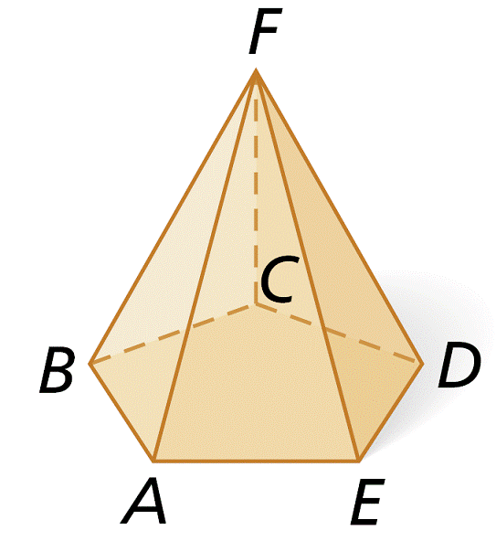

Classify: Rectangular Prism Class:_______________

Verticies: A,B,C,D,E,F,G,H Vert:_________________

Edges: AB,BC,CD,AD,EF,FG Edge:________________

GH,HE,AE,BF,CG,DH

Bases: ABCD, EFGH, ABFE, Base:________________

DCGH, ADHE, BCGF

Example 3: Example 4:

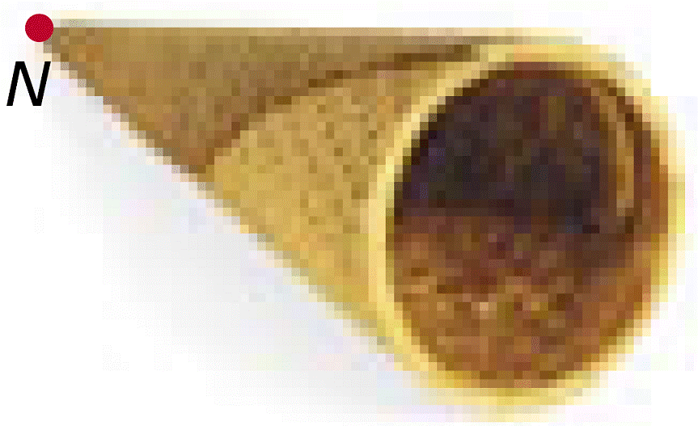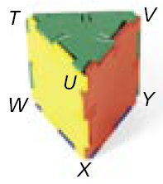

Class:_______________ Class:_______________

Vert:_________________ Vert:_________________

Edge:________________ Edge:________________

Base:________________ Base:________________

A is a diagram of the surfaces of a three-dimensional figure that can be folded to form the three-dimensional figure.

\**Hint *To identify a three-dimensional figure from a net, look at the number of faces and the shape of each face*.

Name the three-dimensional figure that can be made from the given net.

Example 5: Example 6: Example 7:

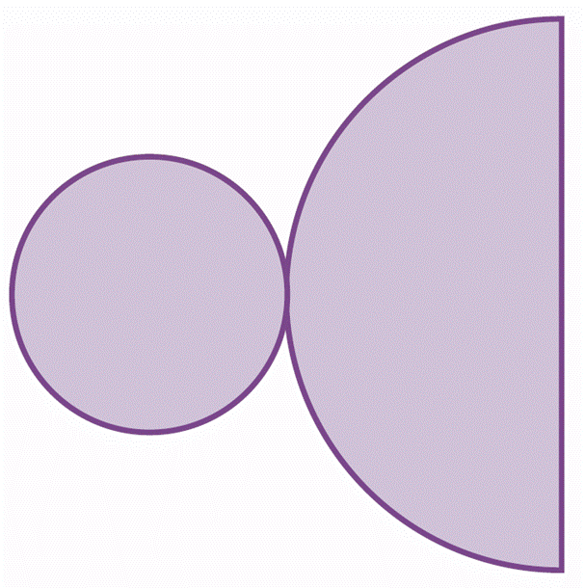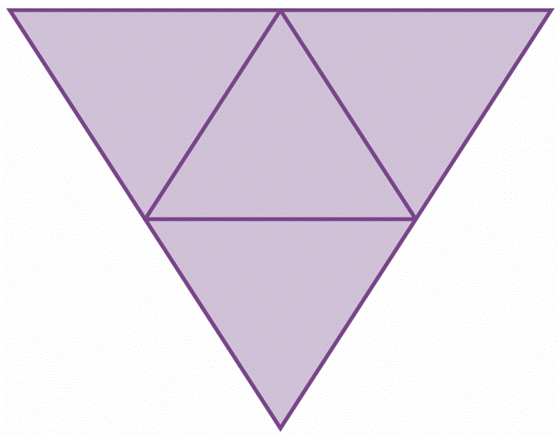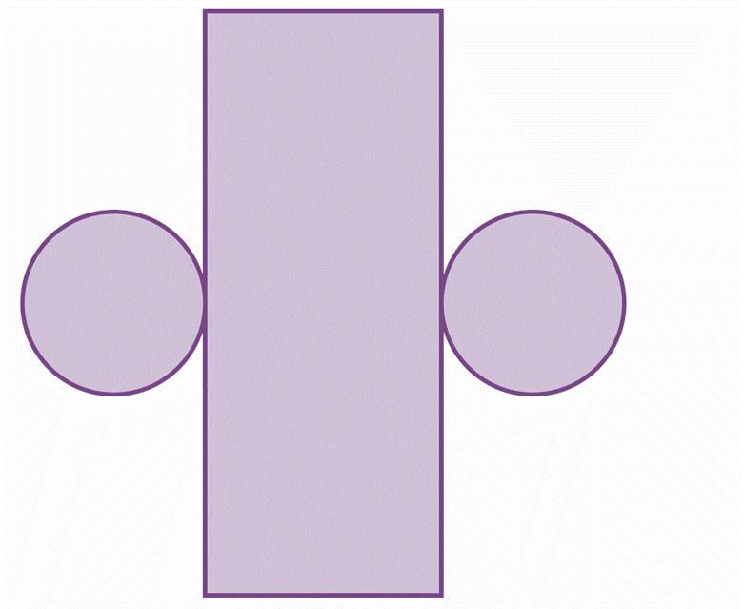

A is the intersection of a three-dimensional figure and a plane.

Describe the cross section.

Example 8: Example 9: Example 10:

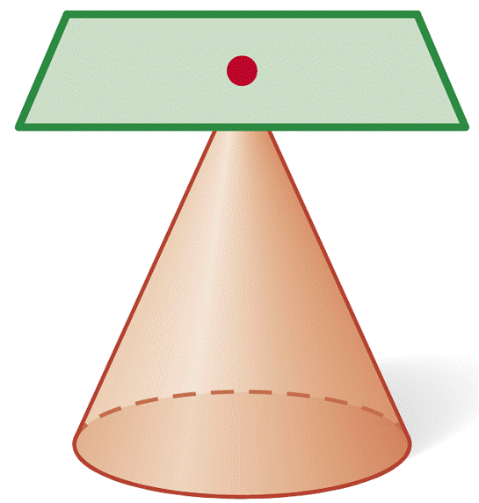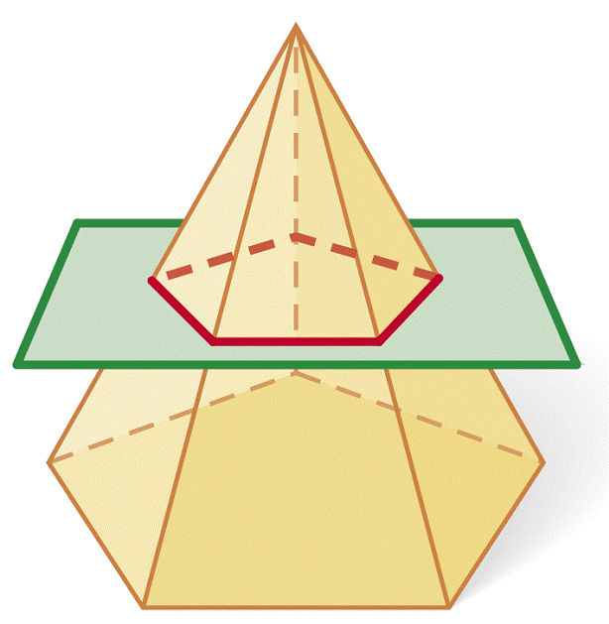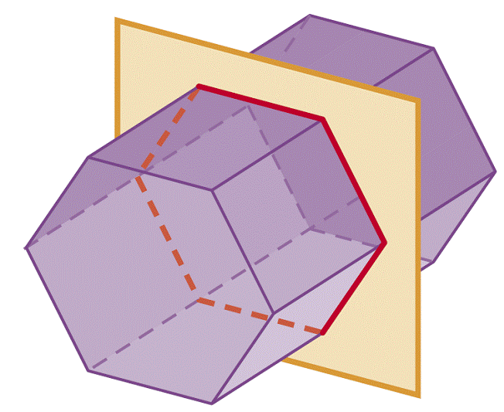

\**Quick Write: Write the definition of a cross section in your own words.*

Homework: Worksheet

|  |
| --- |
| **10.2 Representations of Three-Dimensional Figures** |

**Learning Objectives**: Students will draw representations of three-dimensional figures and recognize a three dimensional figure from a given representation.

There are many ways to represent a three dimensional object.

An shows six different views of an object: top, bottom, front, back, left side, and right side.

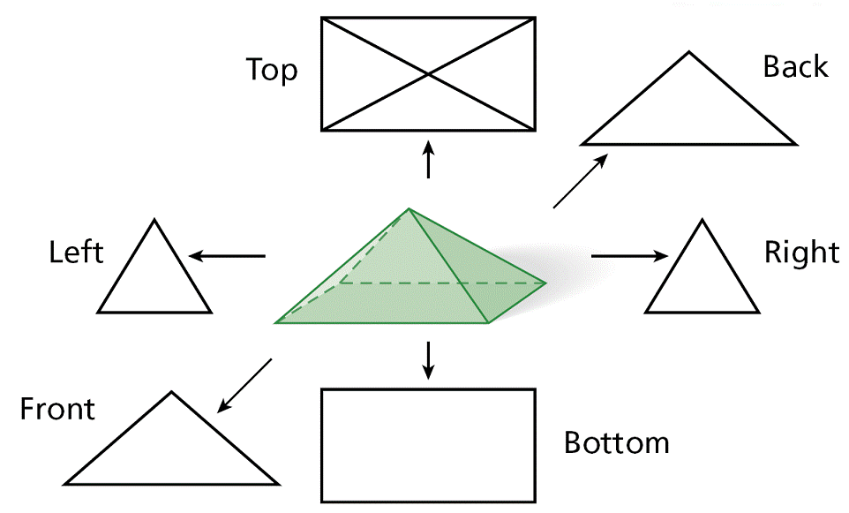

Example 1: Draw all six orthographic views of the given object. Assume there are no hidden cubes.

Front Back Left

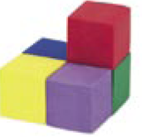

Right Top Bottom

___________________________ is a way to show three sides of a figure from a corner view.

You can use *isometric dot paper* to make an isometric drawing. This paper has diagonal rows of dots that are equally spaced in a repeating triangular pattern.

Example 2: Draw an isometric view of the given object. Assume there are no hidden cubes.

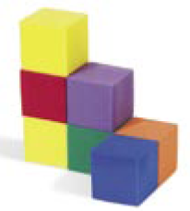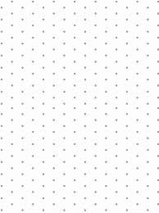

\**Quick Write: Isometric/Orthographic views, which is better and why?*

*____________________________________________________________________________________________________________________________________________________________________________________________________________________________________*

*____________________________________________________________________________________________________________________________________________________________________________________________________________________________________*

Homework: worksheet

|  |
| --- |
| **10.4 Surface Area of Prisms and Cylinders** |

**Learning Objectives**: Students will apply the formula for the surface area of a prism a cylinder.

________________ and have 2 congruent parallel bases.

A *Lateral face* is not a base. The edges of the base are called ___________ . A *Lateral edge* is not an edge of a base, instead it *connects the two bases.*  The lateral faces of a right prism are all __________________. An Oblique Prism has at least one nonrectangular lateral face.

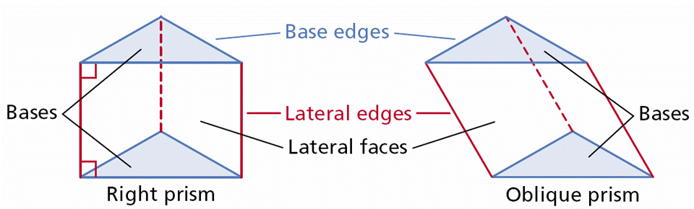

An of a prism or cylinder is a perpendicular segment joining the planes of the bases, this is the height of the figure.

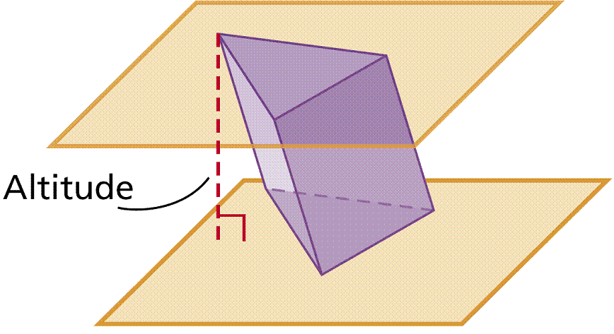

*The height MUST by perpendicular to the base (or to the plane that contains the base).*

___________________is the *total area of all faces* and curved surfaces of a three-dimensional figure. The of a prism is the sum of the areas of ONLY the *lateral faces.*

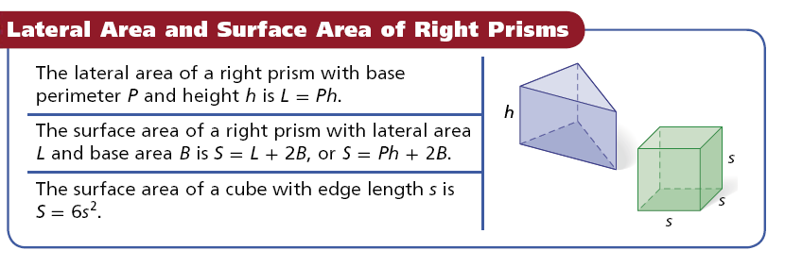

|  |
| --- |
| *The surface area formula is only true for right prisms. To find the surface area of an oblique prism, add the areas of the faces.* |

Example 1: Find the lateral area and surface area of the right rectangular prism. Round to the nearest tenth, if necessary. YOU MUST SKETCH THE BASE.

Lateral Area Base (Sketch) - Area (Total)Surface Area

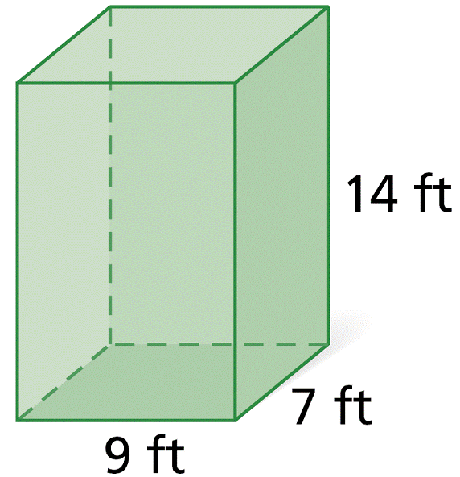

Example 2: Draw a cube. Find the lateral area and surface area if the length of the edge is 8 cm. YOU MUST SKETCH THE BASE.

Lateral Area Base (Sketch) -Area (Total)Surface Area

The of a cylinder is the curved surface that connects the two bases.

The is the segment with endpoints at the centers of the bases. The axis of a is perpendicular to its bases. The axis of an is not perpendicular to its bases. The of a right cylinder is the same length as the axis.

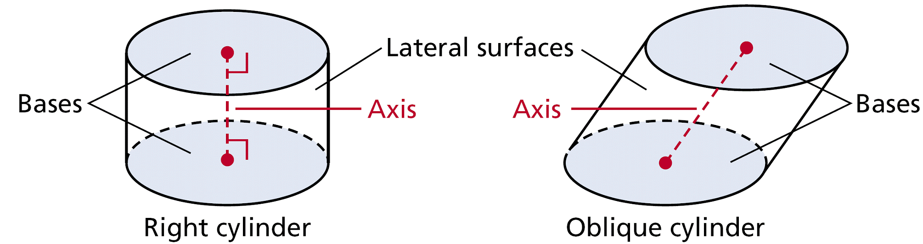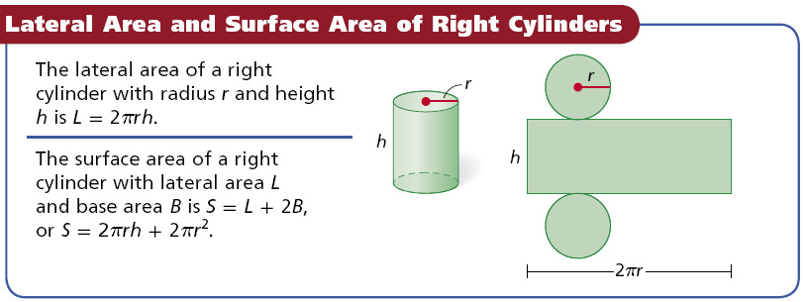

Example 3: Find the lateral area and surface area of the right cylinder. Give your answers in terms of *π*.

Lateral Area Base (Sketch)-Area (Total)Surface Area

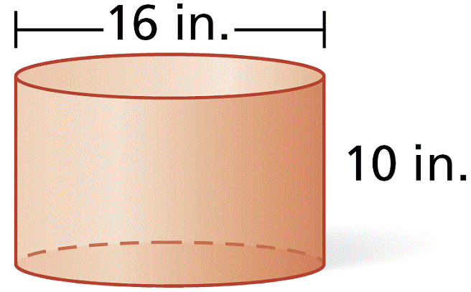

Example 4: Find the lateral area and surface area of a cylinder with a base area of 49*π* and a height that is 2 times the radius.(Label the sketch)

Lateral Area Base (Sketch)-Area (Total)Surface Area

Example 5: Find the surface area of the composite figure.

Rect. Prism Trangular Prism

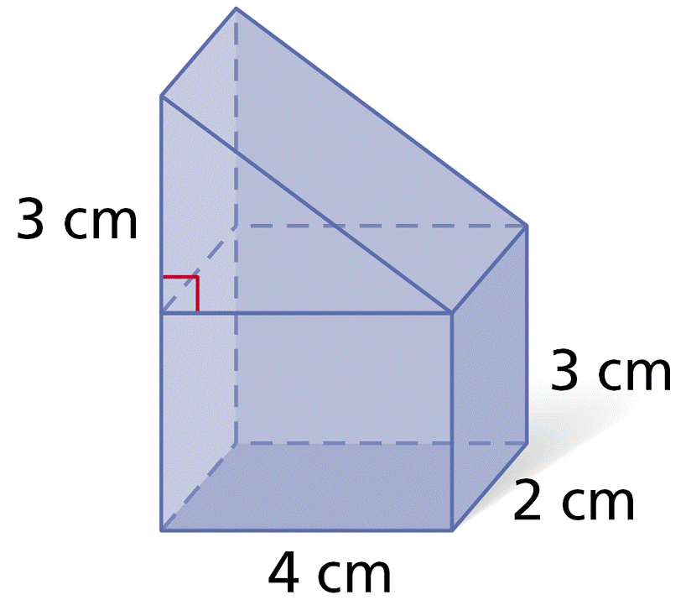

\**Quick Write: (Compare/Contrast) Discuss how prisms/cylinders are similar and how they are different.*

*____________________________________________________________________________________________________________________________________________________________________________________________________________________________________*

*____________________________________________________________________________________________________________________________________________________________________________________________________________________________________*

Homework: Worksheet

|  |
| --- |
| **10.5 Surface Area of Pyramids and Cones** |

**Learning Objectives**: Students will apply the formula for the surface area of a pyramid a cone.

The is the point (peak) opposite the base of the pyramid. The base of a *regular pyramid*  is a _____________________, and the lateral faces are *congruent isosceles triangles*. The is the distance from the vertex to the midpoint of an edge of the base. The is the perpendicular segment from the vertex to the plane of the base.

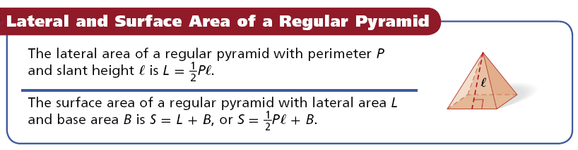

Example 1: Find the lateral area and surface area of a regular square pyramid with base edge length 14 cm and slant height 25 cm. Round to the nearest tenth, if necessary.

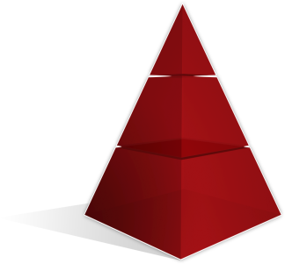

Lateral Area Base (Sketch)-Area (Total)Surface Area

Example 2: Find the lateral area and surface area of the regular pyramid.

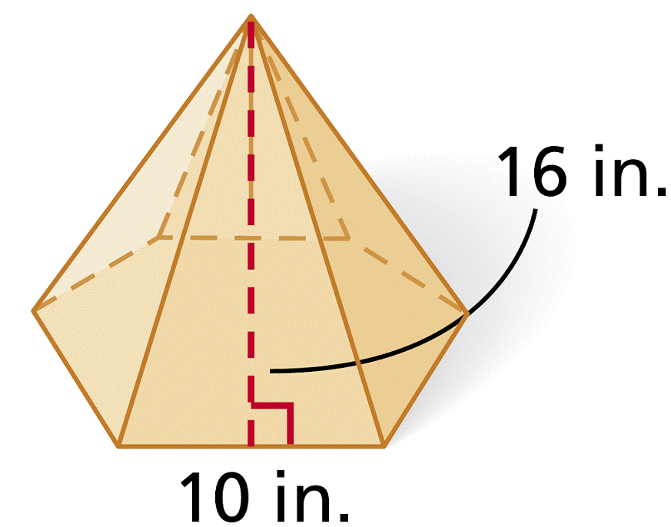

Lateral Area Base (Sketch)-Area (Total)Surface Area

The is the point (peak) opposite the base. The is the segment with endpoints at the vertex and the center of the base. The axis of a *Right Cone* is perpendicular to the base. The axis of an *Oblique Cone* is *not* perpendicular to the base.

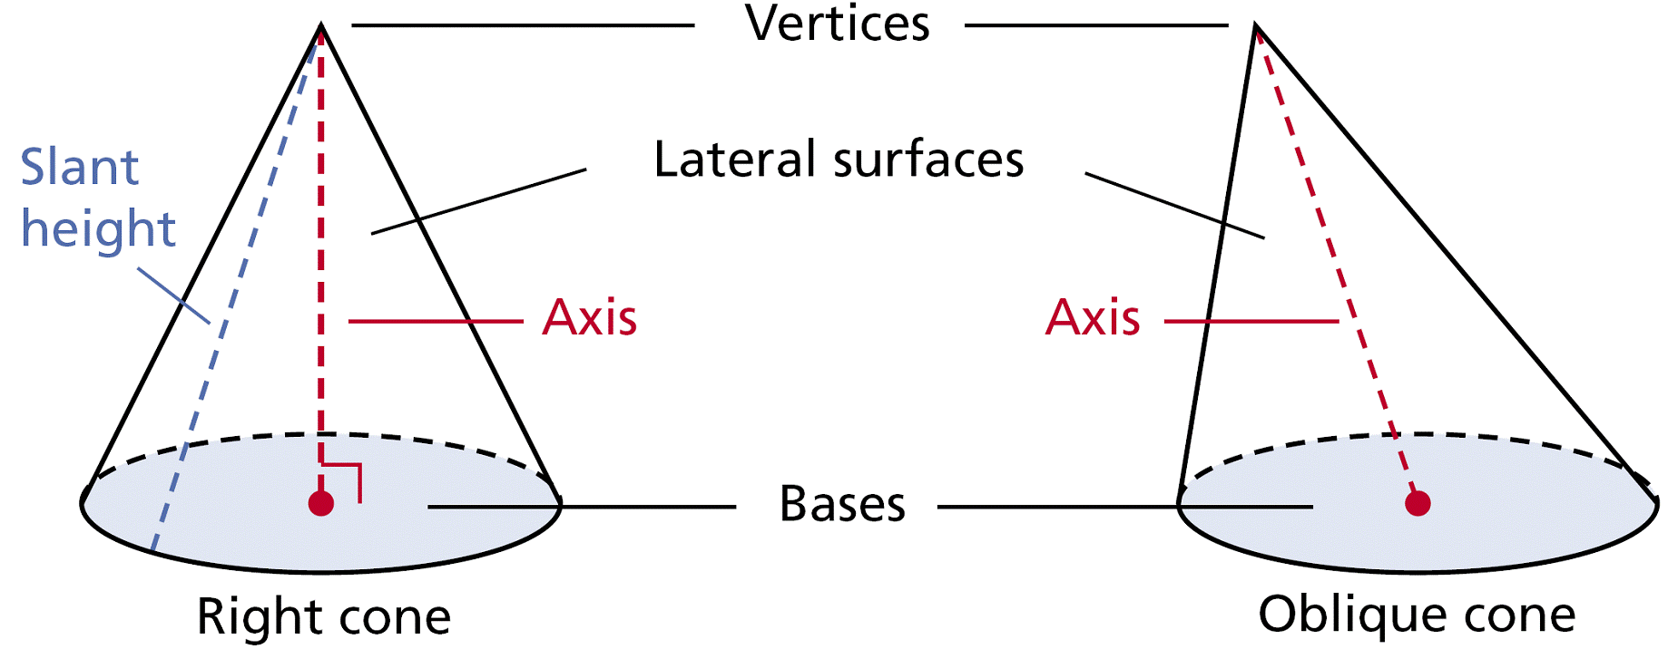

The is the distance from the vertex of a right cone to a point on the edge of the base. The is a perpendicular

segment from the vertex of the cone to the plane of the base (the true height).

Relationship between dimensions in a cone.

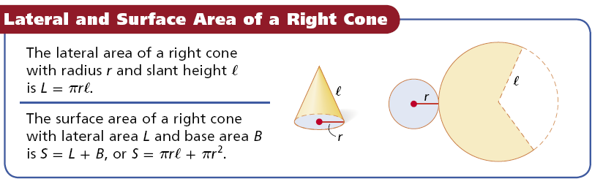

Example 3: Find the lateral area and surface area of a right cone with radius 9 cm and slant height 5 cm.



Lateral Area Base (Sketch)-Area (Total)Surface Area

Example 4: Find the lateral area and surface area of the cone.

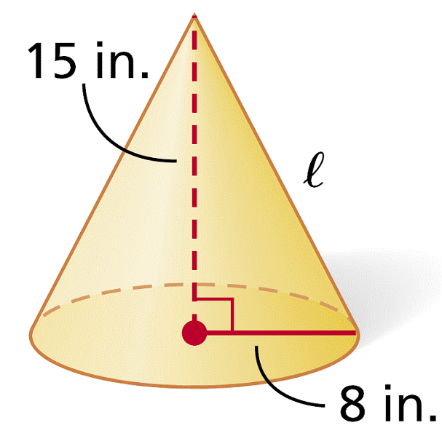

Lateral Area Base (Sketch)-Area (Total)Surface Area

Example 5: Finding Surface Area of Composite Three-Dimensional Figures

Left hand cone: Right hand cone: Total Area:

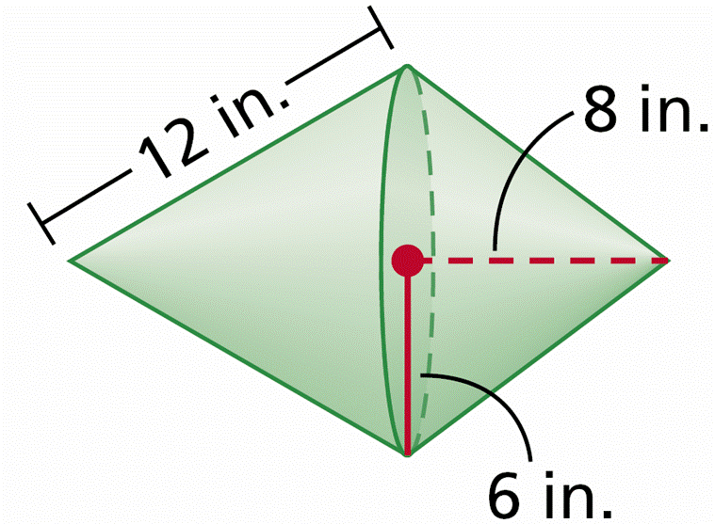

\**Quick Write: What is the difference between slant height and “true” height? How do you find one given the other?*

*____________________________________________________________________________________________________________________________________________________________________________________________________________________________________*

*____________________________________________________________________________________________________________________________________________________________________________________________________________________________________*

Homework: Worksheet

|  |
| --- |
| **10.6 Volume of Prisms and Cylinders** |

**Learning Objectives**: Students will apply the formula for the volume of a prism and a cylinder.

The of a three-dimensional figure is the number of nonoverlapping unit cubes of a given size that will exactly fill the interior.

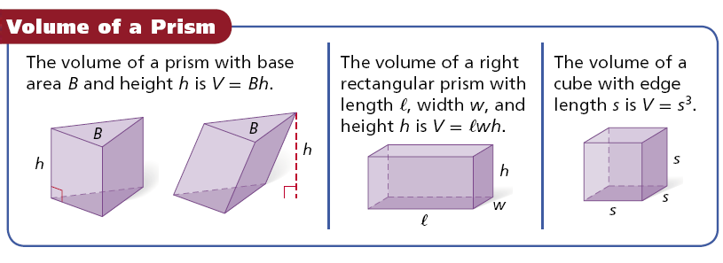

Example 1: Find the volume of the prism.

Base (Sketch)-Area Height Volume

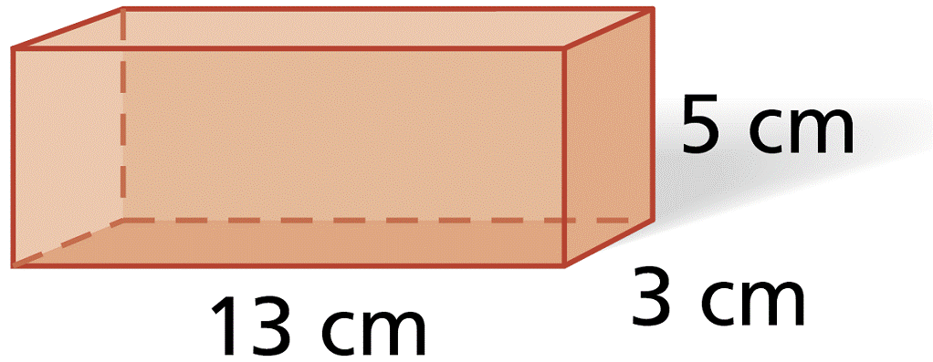

Example 2: Find the volume of the right regular hexagonal prism. Round to the nearest tenth.

Base (Sketch)-Area Height Volume

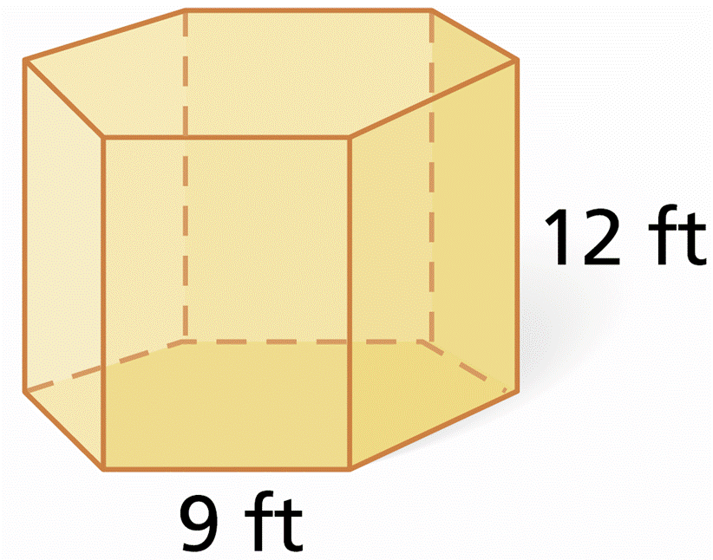

Example 3: A swimming pool is a rectangular prism. Estimate the volume of water in the pool in gallons when it is completely full (Hint: 1 gallon ≈ 0.134 ft3). The density of water is about 8.33 pounds per gallon. Estimate the weight of the water in pounds.

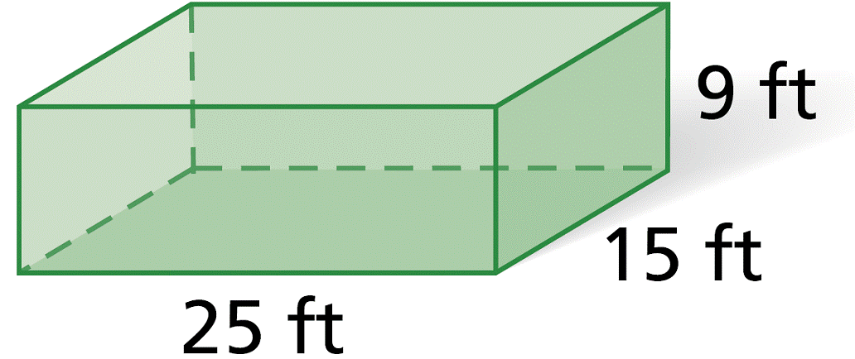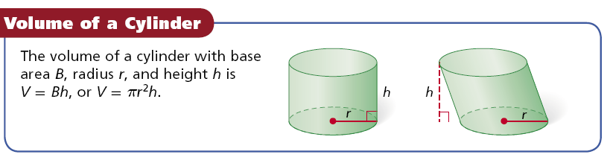

Example 4: Find the volume of the cylinder. Give your answers in terms of *π* and rounded to the nearest tenth.

Base (Sketch)-Area Height Volume

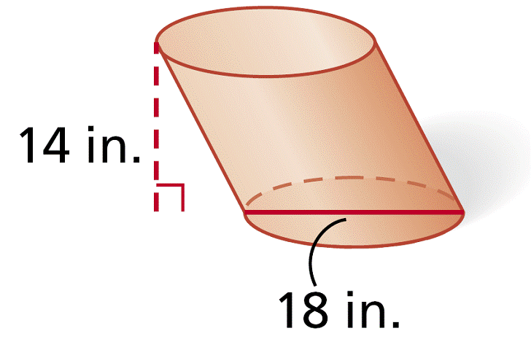

Example 5: Find the volume of a cylinder with a diameter of 16 in. and a height of 17 in. Give your answer both in terms of *π* and rounded to the nearest tenth.

Base (Sketch)-Area Height Volume

Example 6: Find the volume of the composite figure. Round to the nearest tenth.

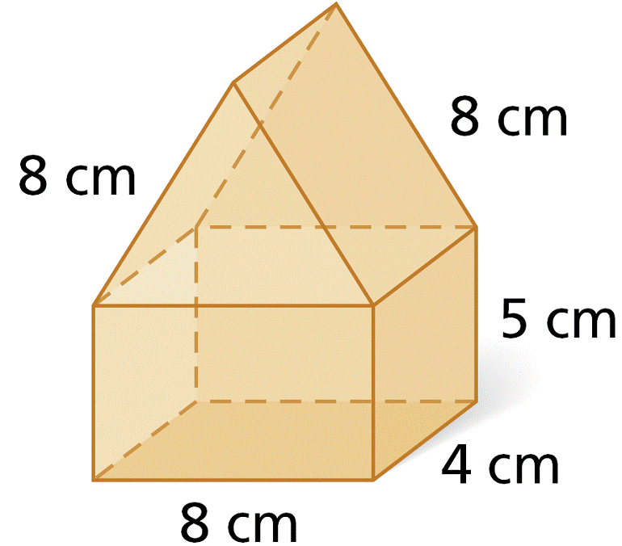

Vol. of Tri. Prism Vol. of Rec. Prism Total Volume

\**Quick Write: Give a real world example of when you would need to find area and volume.*

*____________________________________________________________________________________________________________________________________________________________________________________________________________________________________*

*____________________________________________________________________________________________________________________________________________________________________________________________________________________________________*

Homework: Worksheet

|  |
| --- |
| **10.7 Volume of Pyramids and Cones** |

**Learning Objectives**: Students will apply the formula for the volume of a pyramid and a cone.

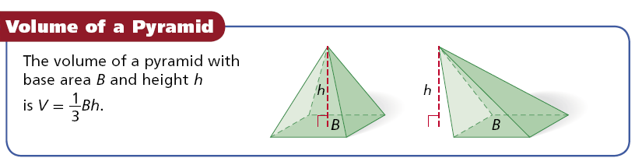

Example 1: Find the volume a rectangular pyramid with length 11 m, width 18 m,

and height 23 m.



Base (Sketch)-Area Height Volume

Example 2: Find the volume of the regular hexagonal pyramid with height equal to the apothem of the base.

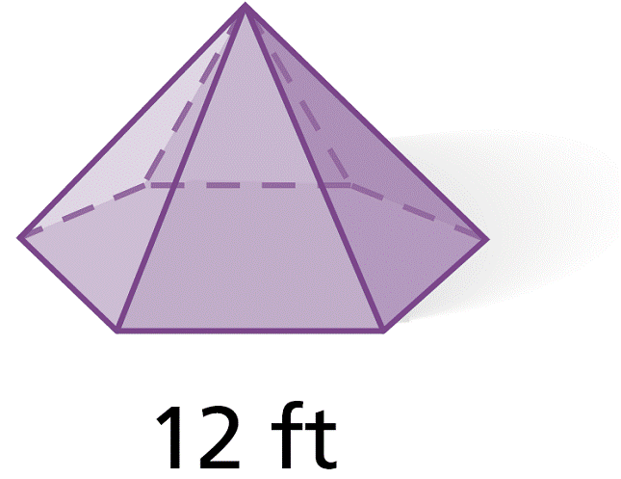

Base (Sketch)-Area Height Volume

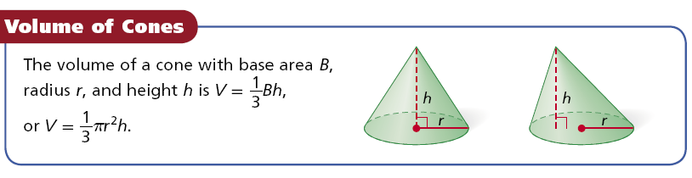

Example 3: Find the volume of a cone with radius 7 cm and height 15 cm. Give your answers both in terms of *π* and rounded to the nearest tenth.



Base (Sketch)-Area Height Volume

Example 4: Find the volume of a cone.

Base (Sketch)-Area Height Volume

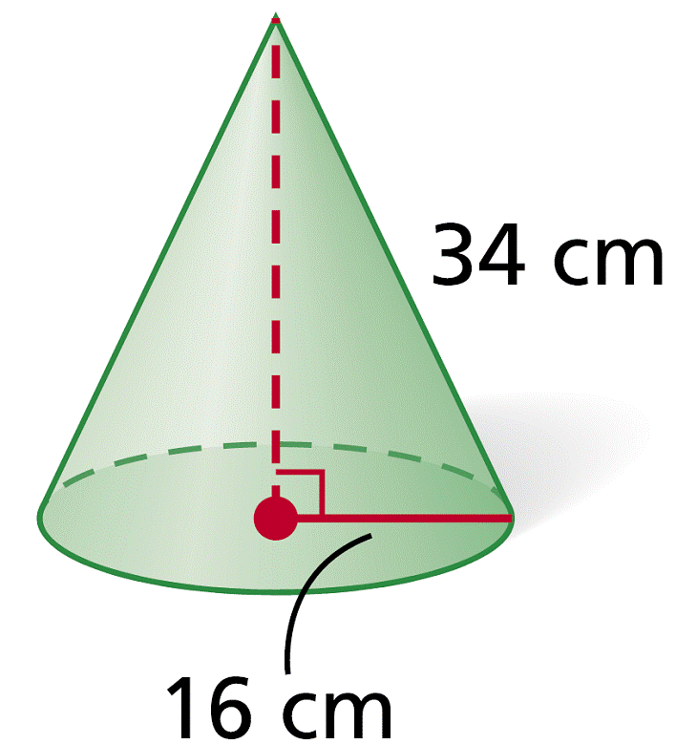

Example 5: Find the volume of the composite figure. Round to the nearest tenth.

Vol. cone1 vol. of cyl. Vol. of cone 2 Total Volume

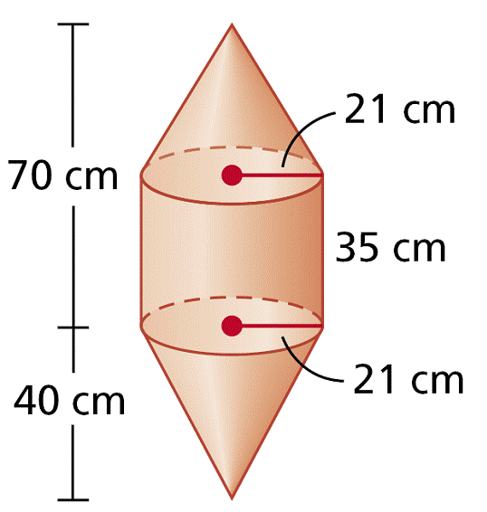

\**Quick Write: How much greater is the volume of a cylinder than that of a cone with the same radius and height? Why? ____________________________________________________________________________________________________________________________________________________________________________________________________________________________________*

*____________________________________________________________________________________________________________________________________________________________________________________________________________________________________*

Homework: Worksheet

|  |
| --- |
| **10.8 Spheres** |

**Learning Objectives**: Students will apply the formula for the volume and surface area of a sphere.

A is the locus of points in space that are a fixed distance from a given point called the . A connects the center of the sphere to any point on the sphere. A is half of a sphere.

A divides a sphere into two hemispheres.

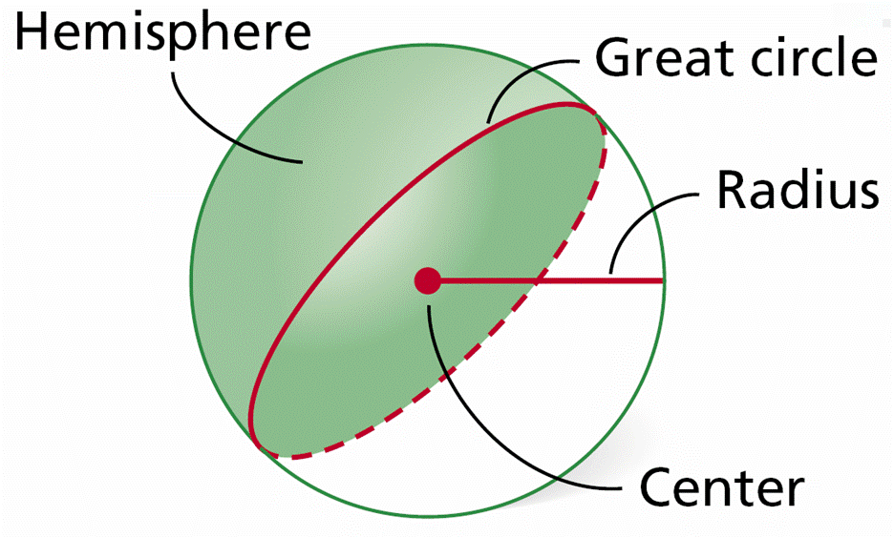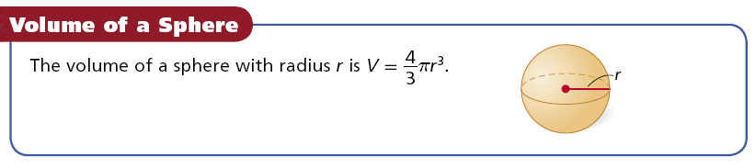

Example 1: Find the volume of the sphere. Give your answer in terms of *π*.

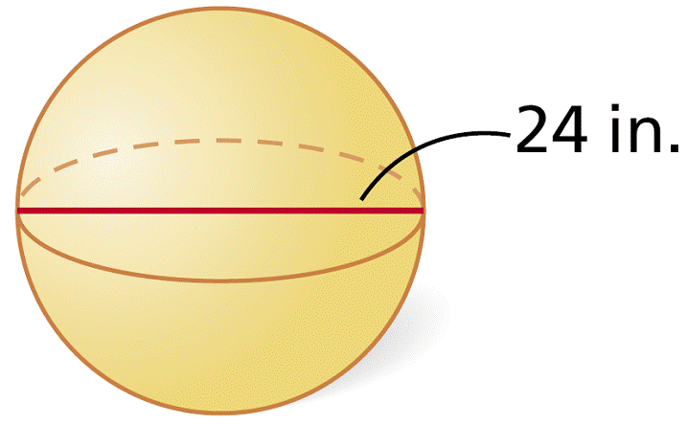

Radius Volume of the Sphere

Example 2: Find the volume of the hemisphere.

Radius Volume of the Hemi-Sphere

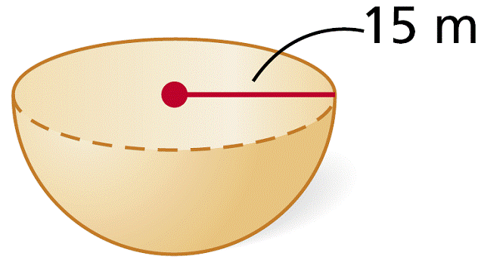

Example 3: Find the radius of a sphere with volume 2304*π* ft3.

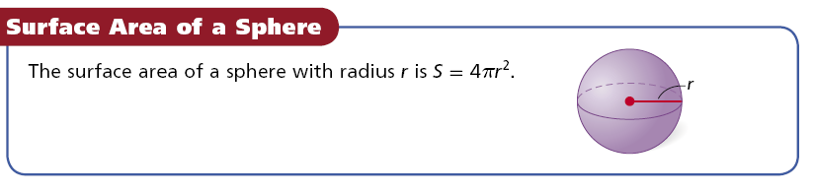

Example 4: Find the surface area of a sphere with diameter 76 cm. Give your answers in terms of *π*.

Radius Surface Area

Example 5: Find the volume of a sphere with surface area 324*π* in2. Give your answers in terms of *π*.

Example 6: Find the surface area of a sphere with a great circle that has an area of 49*π* mi2.

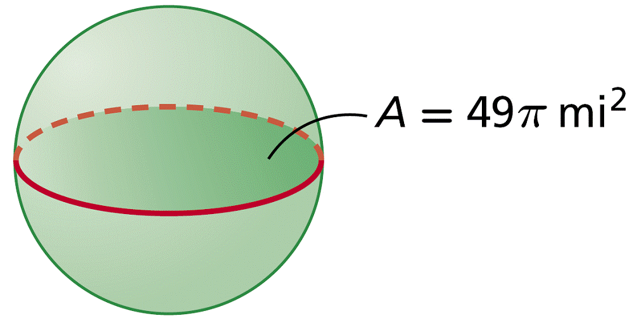

\**Quick Write: In what way(s) do a circle and a sphere differ?*

*____________________________________________________________________________________________________________________________________________________________________________________________________________________________________*

*____________________________________________________________________________________________________________________________________________________________________________________________________________________________________*

Homework: Worksheet

|  |
| --- |
| **Changing Dimensions Proportionally** |

|  |  |  |  |
| --- | --- | --- | --- |
| Change in Dimensions | Perimeter or Circumference | Area | Volume |
| All dimensions multiplied by a | Changes in factor of a | Changes in factor of a2 | Changes in factor of a3 |

Example 1: The edge length of the cube is tripled. Describe the effect on the surface area.

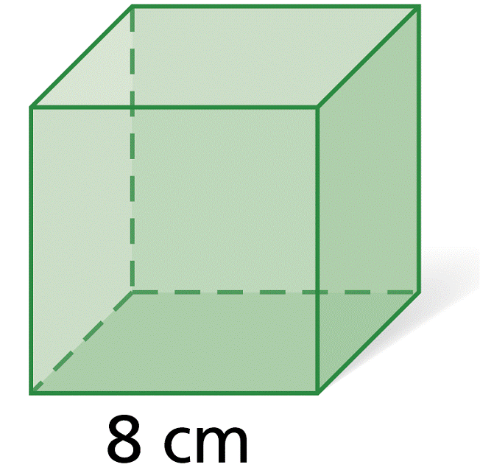

Example 2: The height and diameter of the cylinder are multiplied by 1/2. Describe the effect on the surface area.

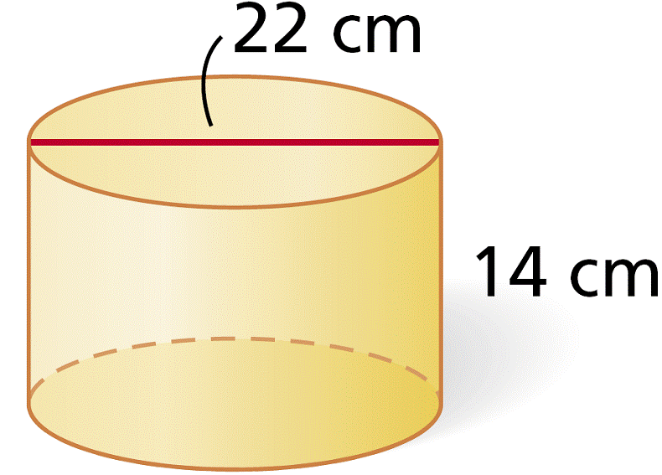

Example 3: The length, width, and height of the prism are doubled. Describe the effect on the volume.

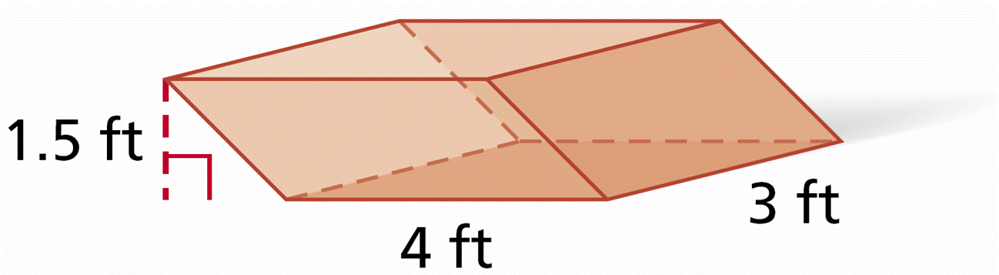

Example 4: The diameter and height of the cone are divided by 3. Describe the effect on the volume.

