1.1 Understanding Points, Lines, and Planes

Learning Goal: Students will identify, name, and draw points, lines, segments, rays, and planes and apply basic facts about points, lines, and planes.

The most basic figures in geometry are , which cannot be defined by using other figures. The undefined terms , , and are the building blocks of geometry.

Term and Definition | How to Label | Draw it
Point

Line

Plane

Patty Paper Fun:

- (page 5)Draw 2 points on patty paper and fold so that the crease passes through the 2 points.
Can you put a second crease on the paper through the same 2 points? Why or Why not?
________________________________________________________________________________________________________________________________________________________________________
- (Page 11) Fold a line on patty paper. Unfold. Fold a second line. Unfold.
Repeat the 2 folds on several pieces of patty paper (use different folds)
How many points of intersection are there for 2 lines?: _______________

- (Page 1) Fold a piece of patty paper in half.
If each half represents a plane, describe the shape formed by the intersection: ___________________

Points that lie on the same line are _____, otherwise they are _______________________.
Points that lie on the same plane are ___, otherwise they are ____________________.
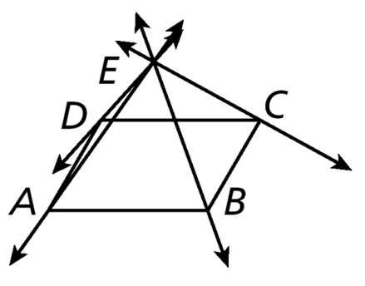
Example 1: A. Name four coplanar points
B. Name three lines.

Term and Definition | How to Label it | Draw it
Segment

Endpoint

Ray

Opposite Rays

Example 2: A. Draw a segment with endpoints M and N.

B. Draw opposite rays with a common endpoint T.

c. Draw and label a ray with endpoint M that contains N.

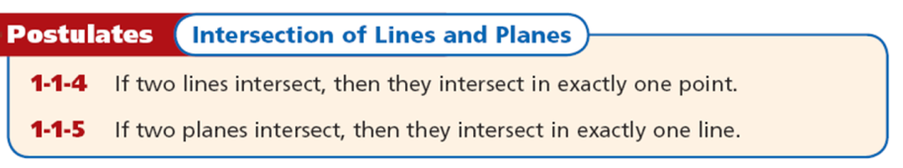
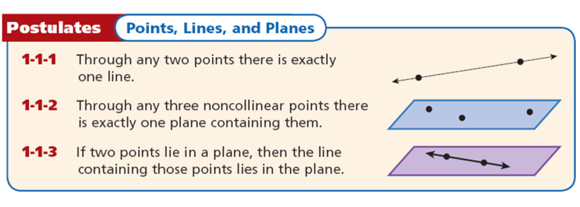
A , or axiom, is a statement that is accepted as true without proof. Postulates about points, lines, and planes help describe geometric properties.

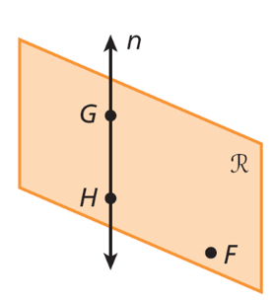

Example 3: Name a plane that contains three noncollinear points.
or

Example 4: A. Sketch two lines intersecting in exactly one point.

B. Sketch a figure that shows two lines intersect in one point in a plane, but only one of the lines lies in the plane.

Homework: Page 9, 14-26 Evens, 31-34.
1.2 Measuring and Constructing Segments

Learning Goal: Students will use length and midpoint of a segment and construct midpoints and congruent segments.

A ruler can be used to measure the distance between two points. A point corresponds to one and only one number on a ruler. The number is called a . The following postulate summarizes this concept.
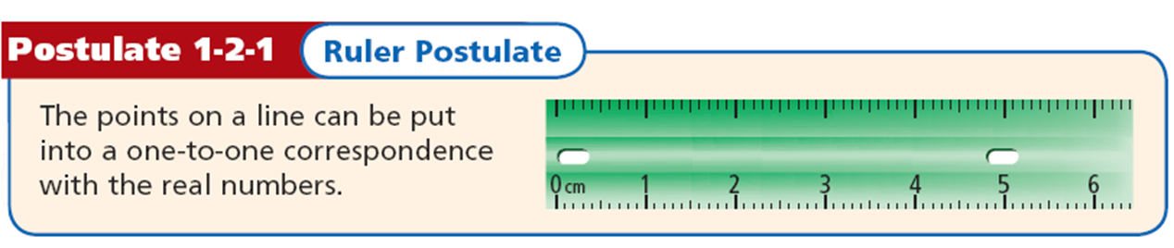

The between any two points is the absolute value of the difference of the coordinates. If the coordinates of points A and B are a and b, then the distance between A and B is |a – b| or |b – a|. The distance between A and B is also called the of $\overline{AB}$, or AB.
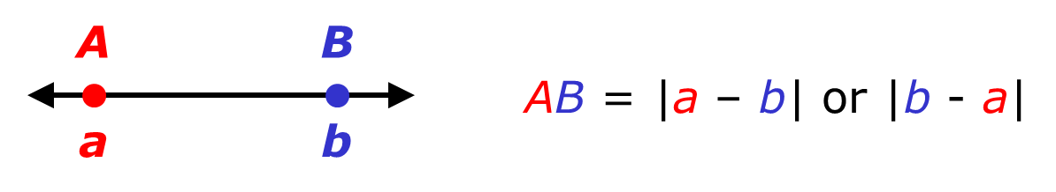
Example 1: A. Find length XY
B. Find length ZY
C. Find length YZ
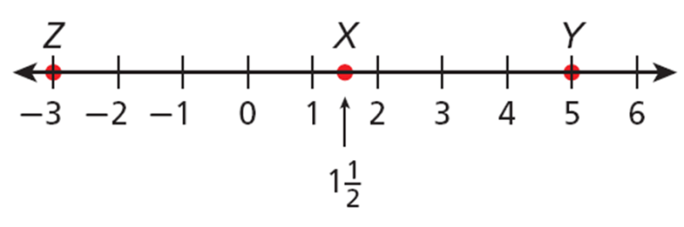
Why are all the lengths in Example 1 positive? __________________________________________________
_________________________________________________________________________________________
_________________________________________________________________________________________

_________________________________ are segments that have the same length. In the diagram below PQ = RS, so you can write $\overline{PQ}$ $≅$ $\overline{RS}$. This is read as “segment PQ is congruent to segment RS.”
are used in a figure to show congruent segments.
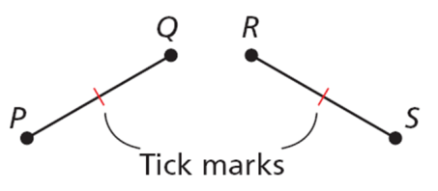

Construct 2 congruent segments:
Construction | Describe the process in your words
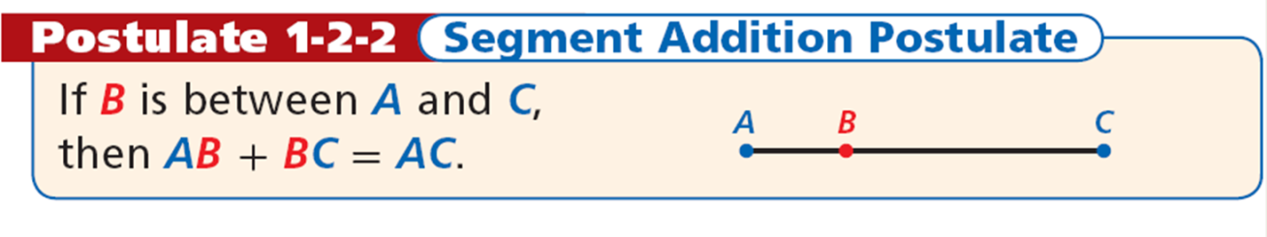
Restate Postulate in your own words. | Draw a diagram
Example 3: A: Y is between X and Z, XZ = 3, and XY = 1 ⅓. Find YZ.

B: E is between D and F. Find DF.

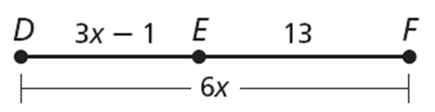
The , M of $\overline{AB}$ is the point that bisects, or divides, the segment into two congruent segments. If M is the midpoint of $\overline{AB}$, then AM = MB.
So if AB = 6, then AM = 3 and MB = 3.

Example 4: You are 1182.5 m from the first-aid station. What is the distance to a drink station located at the midpoint between your current location and the first-aid station?
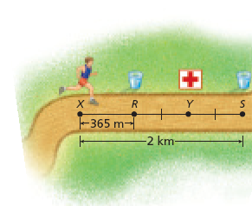
Example 5: D is the midpoint of EF, ED = 4x + 6, and DF = 7x – 9. Find ED, DF, and EF.

ED = DF = EF =

Draw the midpoint of a line segment | Describe the procedure in your own words

Homework: Page 17, 12-22 Even, 28,32
1.3 Measuring and Constructing Angles

Learning Goal: You should be able to name, classify, measure and construct angles and angle bisectors.

An is a figure formed by two rays, or sides, with a common endpoint called the (plural: vertices). You can name an angle several ways: by its vertex, by a point on each ray and the vertex, or by a number.
The set of all points between the sides of the angle is the of an angle. The of an angle is the set of all points outside the angle.
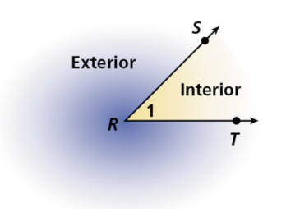Angle Name: , , ,

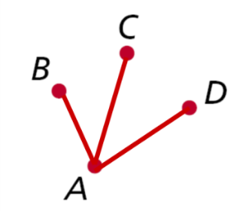
Example 1: A surveyor recorded the angles formed by a transit (point A) and three distant points, B, C, and D. Name three of the angles.
, ,
Explain why the angle in the above diagram cannot be named Angle A: ______________________________________________________________
______________________________________________________________
______________________________________________________________

Type of Angle and Definition | Draw an Example and Label Properly
Acute

Right

Obtuse

Straight

Example 2: Find the measure of each angle. Then classify each as acute, right, or obtuse.
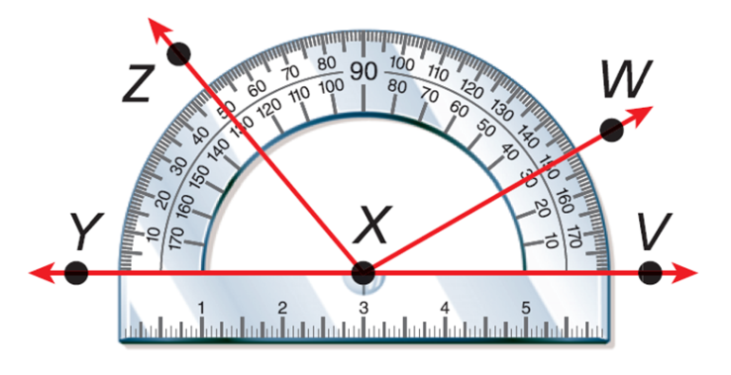
A. m∠WXV = B. m∠ZXW =
Classify: Classify:

________________________________ are angles that have the same measure. In the diagram, m∠ABC = m∠DEF, so you can write ∠ABC ≅ ∠DEF. This is read as “angle ABC is congruent to angle DEF.”
are used to show that the two angles are congruent.
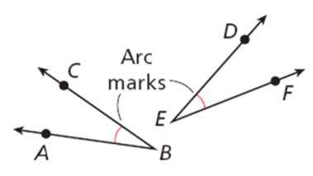
Draw 2 congruent angles | Describe the Steps to this procedure

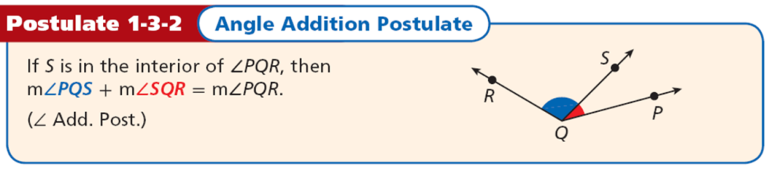
Restate the Postulate in your own words. | Draw it.
Example 3: m∠DEG = 115°, and m∠DEF = 48°. Find m∠FEG
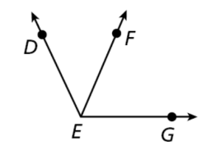
An is a ray that divides an angle into two congruent angles.
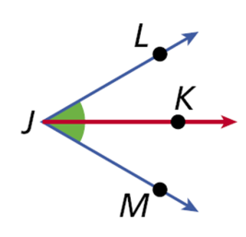
JK bisects ∠LJM; thus ∠LJK ≅ ∠KJM.

Construct an Angle Bisector | Describe the Steps to this procedure
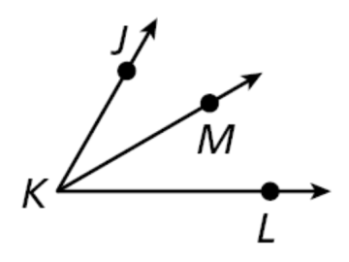
Example 4: KM bisects ∠JKL, m∠JKM = (4x + 6)°, and m∠MKL = (7x – 12)°. Find m∠JKM.

X = m∠JKM =

Homework: Page Page 24: 12-22, 27,29-31
1.4 Pairs of Angles

Learning Goal: You should be able to identify and find the measures of adjacent, vertical, complementary, and supplementary angles.

Fun with Patty Paper
- Fold a line on patty paper. Unfold. Fold a second line intersecting the first line. Unfold.
Label all the angles.
What seems to be true about the verticle angles? _________________________________________________________________________________
- Fold a line on patty paper. Unfold. Fold a second line intersecting the first line. Unfold.
Label all the angles.
Name each pair of adjacent angles on the paper: _____________
_____________
______________
______________
What seems to be true about each linear pair of angles in the picture:
_____________________________________________________________________

Pairs of Angles | Draw it
Adjacent Angles

Linear Pair

Tell whether the angles are only adjacent, adjacent and form a linear pair, or not adjacent.
Example 1A: ∠AEB and ∠BED 1B: ∠AEB and ∠BEC 1C: ∠DEC and ∠AEB

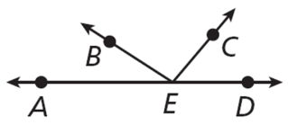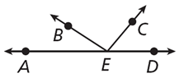

Type of Angle | Draw it
Complementary Angles

Supplementary Angles

You can find the complement of an angle that measures x° by subtracting its measure from 90°, or
You can find the supplement of an angle that measures x° by subtracting its measure from 180°, or
Example 2: Find the measure of each of the following.
A. complement of ∠F B. supplement of ∠G

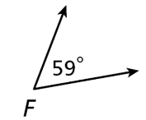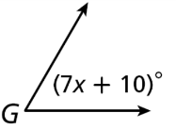
Example 3: An angle is 10° more than 3 times the measure of its complement. Find the measure of the complement.

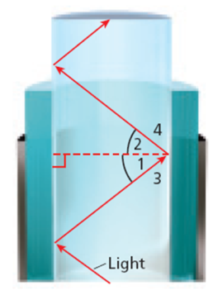
Example 4: Light passing through a fiber optic cable reflects off the walls of the cable in such a way that ∠1 ≅ ∠2, ∠1 and ∠3 are complementary, and ∠2 and ∠4 are complementary.
If m∠1 = 47°, find m∠2, m∠3, and m∠4.

Another angle pair relationship exists between two angles whose sides form two pairs of opposite rays. are two nonadjacent angles formed by two intersecting lines. are vertical angles, as are .
Type of Angle | Draw it
Vertical Angles

Example 5: Name the pairs of vertical angles.

And and

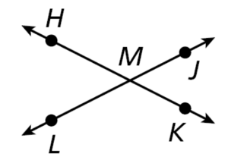

Homework: Page 32, # 14-30 Even, 34-37

12.1 Reflections

Learning Goal: Students will ID and draw reflections.
Fun with Patty Paper

- Construct a simple shape on your patty paper. Place a line on your patty paper that does not intersect your shape. This line will be your line of reflection.
- Fold the Patty paper along the line of reflection. Trace your shape onto the folded portion of your patty paper. Unfold. You have performed a reflection.
- Draw a segment connecting a point in the original figure and the corresponding point in the reflected image. Repeat for a second point.
- The line of reflection divides each segment connecting a point and its image in a special way. Compare the two parts of each segment.
How do their lengths compare? __________________________________________________
What is the angle between each segments and the line of reflection? ____________________

An isometry is a transformation that does not change the shape or size of a figure. Reflections, translations, and rotations are all isometries. Isometries are also called congruence transformations or rigid motions.

Recall that a reflection is a transformation that moves a figure (the preimage) by flipping it across a line. The reflected figure is called the image. A reflection is an isometry, so the image is always congruent to the preimage.

Example 1: Tell whether each transformation appears to be a reflection. Explain.

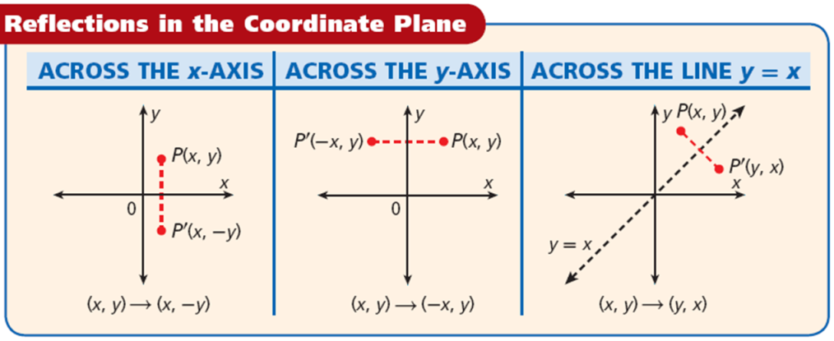

Example 2: Reflect the figure with the given vertices across the given line.
X(2, –1), Y(–4, –3), Z(3, 2); x-axis
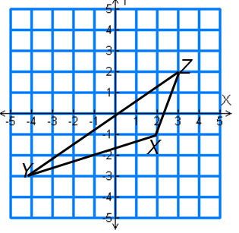
R(–2, 2), S(5, 0), T(3, –1); y = x
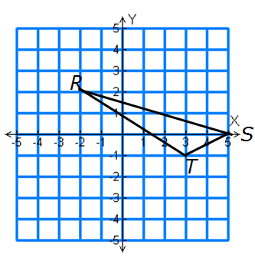
S(3, 4),
T(3, 1), U(–2, 1) and V(–2, 4) across the x-axis
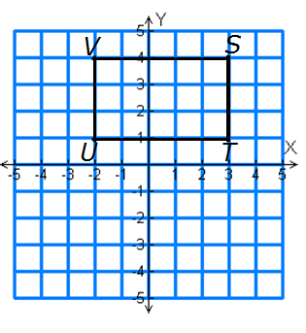
Homework: Page 827, 2-21
12.2 Translations

Learning Goal: Students will ID and draw translations.

Fun with Patty Paper

- Construct a simple shape on your patty paper. Place a dot in its interior.
- Draw a ray from that dot to an edge of your patty paper. This will determine the direction of your translation.
- Place a second dot on the ray. The distance from the first dot to the second dot will be the translation distance.
- Place a second patty paper over the first, and trace the figure, interior dot, and the ray.
- Slide the second patty paper along the path of the ray until the dot on the tracing is over the second dot on the original.
- Use another patty paper to measure the distance between a point in the original shape and its corresponding point in the translated image.
- Try this with several other corresponding points.
Quick Write: Compare your results with several other students. Write your observations. What can you say about the distances?
______________________________________________________________________________________________________________________________________________________________________________________________________________________________________________________________________________________________________

A translation is a transformation where all the points of a figure are moved the same distance in the same direction. A translation is an isometry, so the image of a translated figure is congruent to the preimage.

Example 1: Tell whether each transformation appears to be a translation.
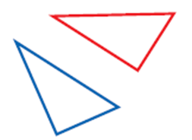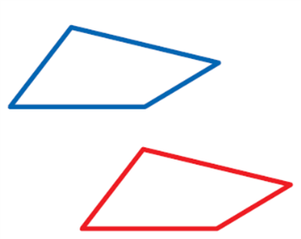

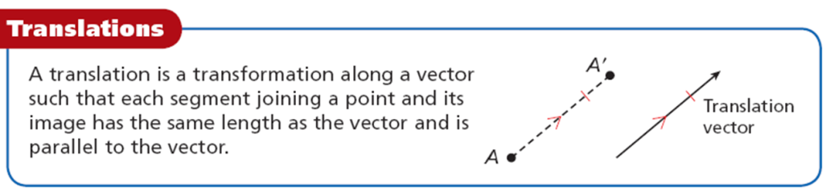

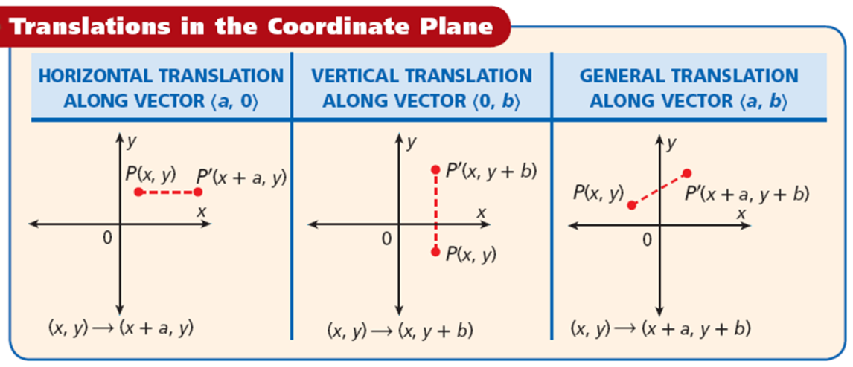

Example 2:
Translate the triangle with vertices D(–3, –1), E(5, –3), and F(–2, –2) along the vector <3, –1>.

Translate the quadrilateral with vertices R(2, 5), S(0, 2), T(1,–1), and U(3, 1) along the vector
<–3, –3>.

Homework: Page 834, 1-22

12.3 Rotations

Learning Goal: Students will ID and draw rotations

Fun with Patty Paper

- Draw a simple shape on your patty paper. Place a dot on the shape on in the interior of the shape. Place a second dot on your patty paper. This second dot will be your center of rotation.
- Draw a ray from the second dot (center of rotation) passing through the first dot. Draw a second ray from the center of rotation to create an angle of rotation.
- Place a second patty paper over the first and trace the figure, the dots, and the first ray.
- Place the tip or eraser of your pencil on the center of rotation and turn the second patty paper through the angle of rotation. You have performed a rotation. Copy the original so that the original and the rotated image are on the same patty paper.
- Use another patty paper to measure the distance between one point in the original shape and its corresponding point in the rotated image. Try this with another pair of corresponding points.
Quick write: What did you observe from #5 above. Are the distances always the same like a translation? Did students around you get the same results?
________________________________________________________________________________________________________________________________________________________________________________________________________________________________________________________________________________________________________________________________________________________________________________________________________

Remember that a rotation is a transformation that turns a figure around a fixed point, called the center of rotation. A rotation is an isometry, so the image of a rotated figure is congruent to the preimage.

Example 1: Tell whether each transformation appears to be a rotation. Explain.
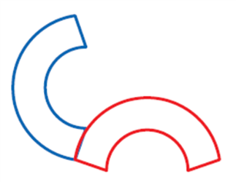
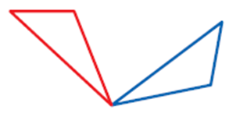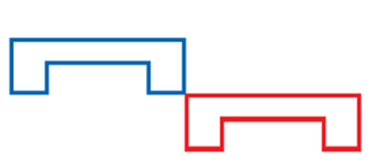

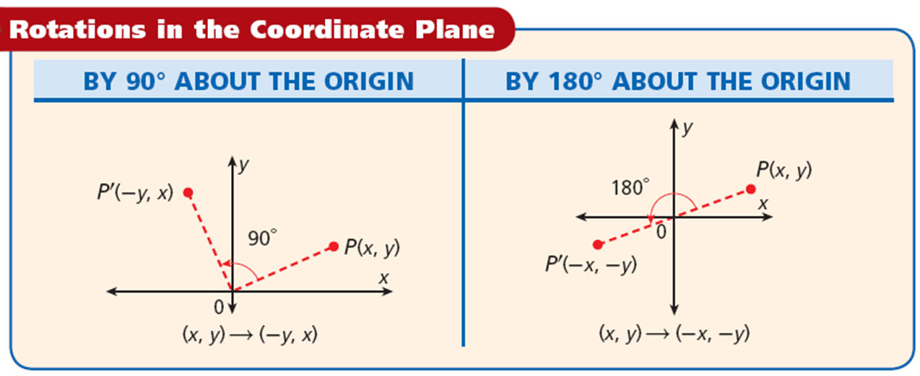

Example #2
Rotate ΔJKL with vertices J(2, 2), K(4, –5), and L(–1, 6) by 180° about the origin.

Rotate ∆ABC by 180° about the origin.
A(2, –1)
B(4, 1)
C(3, 3)

Homework: Page 842, 1-25

12.4 Compositions of Transformations

Learning Goal: Students will ID and draw compositions of transformations.

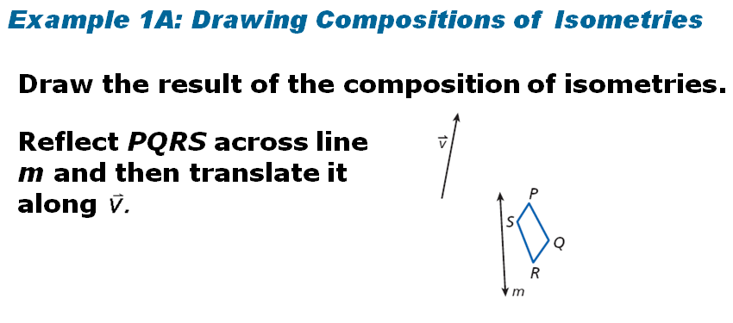
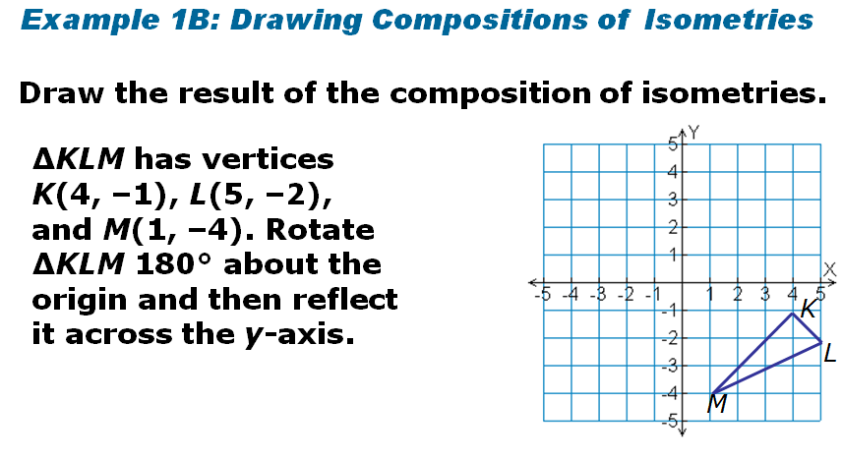
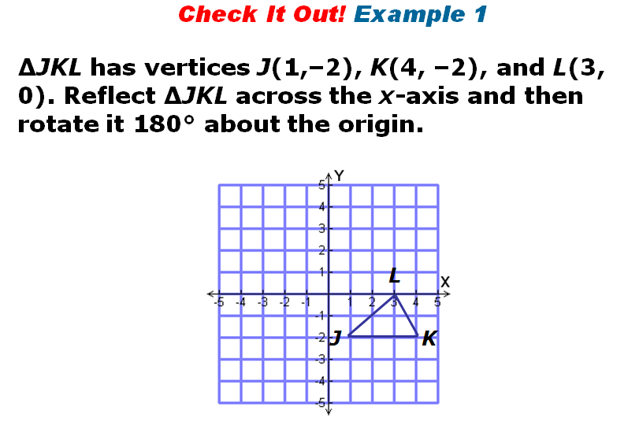

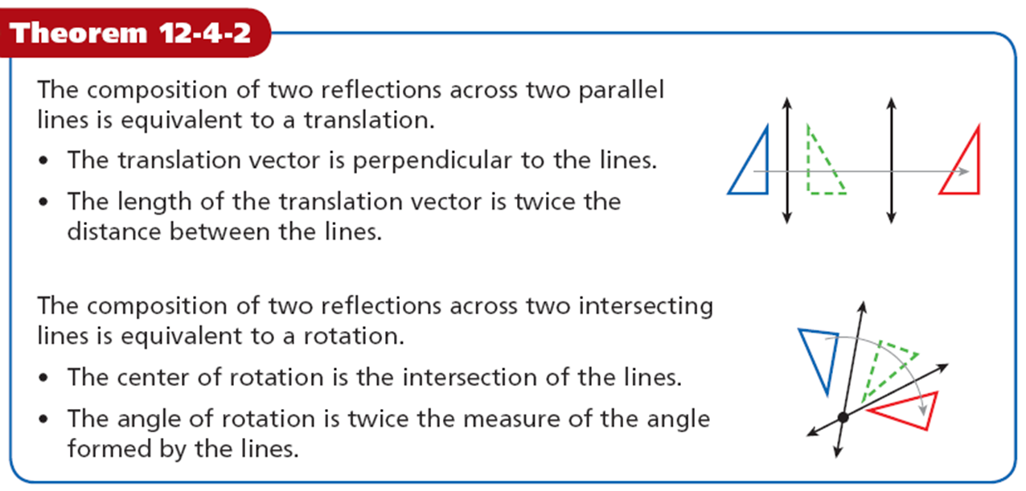
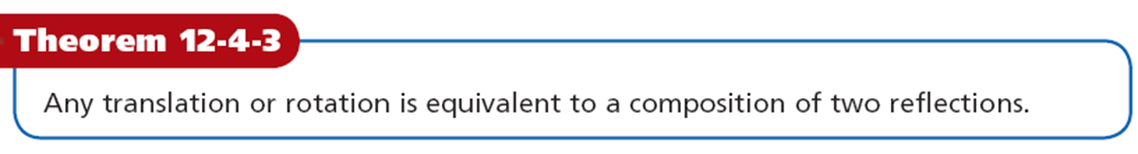

Homework: Page 851 2-13

