|  |
| --- |
| **5.1 Perpendicular and Angle Bisectors** |

**Learning Goals**: Students will apply theorems about perpendicular bisectors and angle bisectors.

When a point is the same distance from two or more objects, the point is said to be ________________from the objects. Triangle congruence theorems can be used to prove theorems about equidistant points.

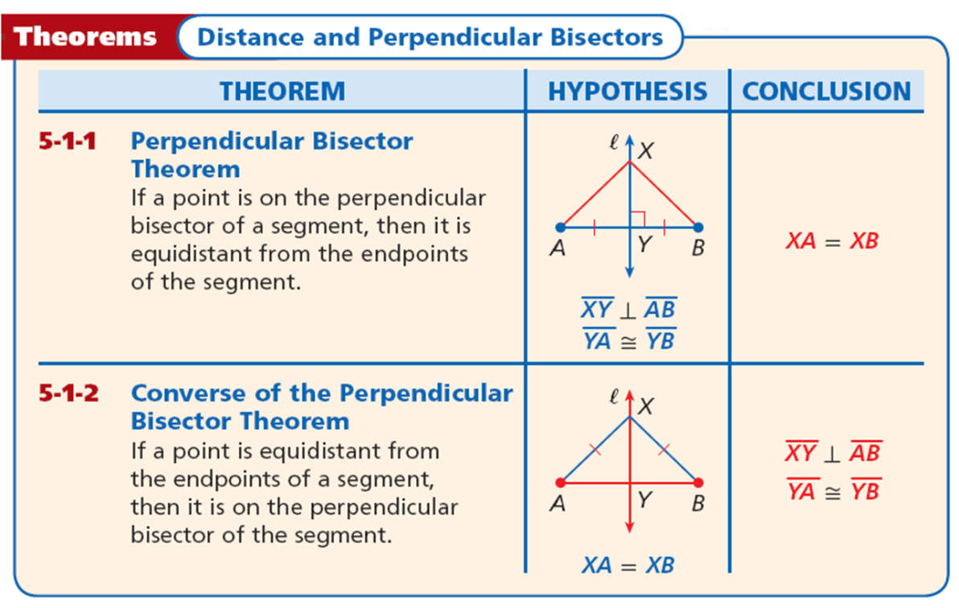

A __________is a set of points that satisfies a given condition. The perpendicular bisector of a segment can be defined as the locus of points in a plane that are equidistant from the endpoints of the segment.

|  |  |
| --- | --- |
| Example 1A Find the measure of **MN.** | Example 1B Find the measure of **BC.** |
| Example 1C Find the measure of **TU.** | Example 1D Given that *DE* = 20.8, *DG* = 36.4  and *EG* =36.4, find ***EF*.** |

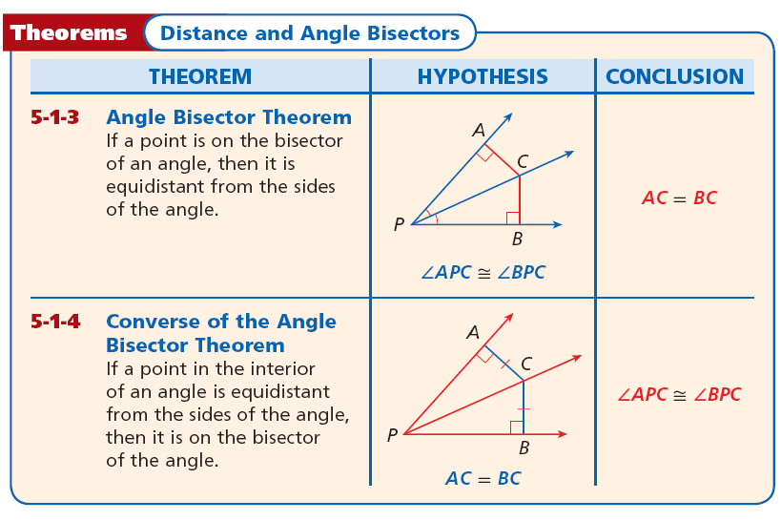

Based on these theorems, an _______________ can be defined as the ***locus of all points*** in the interior of the angle that are ***equidistant from the sides of the angle.***

|  |  |
| --- | --- |
| Example 2A:  Find the measure of **BC.** | Example 2B: Find the measure of **m∠*EFH*** given that m∠*EFG* = 50°. |
| Example 2C **Find m∠*MKL.*** | Example 2D Given that *YW* bisects ∠*XYZ* and *WZ* = 3.05, find ***WX*.** |
| Example 2E Given that m∠*WYZ* = 63°, *XW* = 5.7, and *ZW* = 5.7, find m∠*XYZ*. | Make up a problem and have your partner solve it: |

HW: P304 2-8,12-18,22-28

|  |
| --- |
| **5.2 Bisectors of Triangles** |

**Learning Goals:** Students will apply properties of perpendicular and angle bisectors of a triangle.

**Fun with Patty Paper #1**

1. Draw a large acute Scalene Triangle on your patty paper.
2. Fold to construct the perpendicular bisector of each side of your triangle.
3. Draw a large obtuse triangle on your patty paper.
4. Fold to construct the perpendicular bisector of each side of your triangle.  
   Compare your results and write what you have observed. ________________________________________________________________________________________________________________________________________________________________________________
5. Measure from the intersection of the perpendicular bisectors to each vertex. What do you observe? ________________________________________________________________________________________________________________________________________________________________________________
6. Draw a right triangle on your patty paper.
7. Fold to construct the perpendicular bisector of each side of your triangle.  
   What do you observe? ________________________________________________________________________________________________________________________________________________________________________________

**Fun with Patty Paper #2**

* 1. Draw a large acute Scalene Triangle on your patty paper.
  2. Fold to construct the angel bisector of each side of your triangle.
  3. Draw a large obtuse triangle on your patty paper.
  4. Fold to construct the angle bisector of each side of your triangle.  
     Compare your results and write what you have observed. ____________________________________________________________________________________________________________________________________________________________________
  5. Measure from the intersection of the angel bisectors to each side. What do you observe? ____________________________________________________________________________________________________________________________________________________________________
  6. Draw a right triangle on your patty paper.
  7. Fold to construct the angel bisector of each side of your triangle.  
     What do you observe? ____________________________________________________________________________________________________________________________________________________________________

Since a triangle has ________ sides, it has three perpendicular bisectors. When you construct the __________________, you find that they have an interesting property.

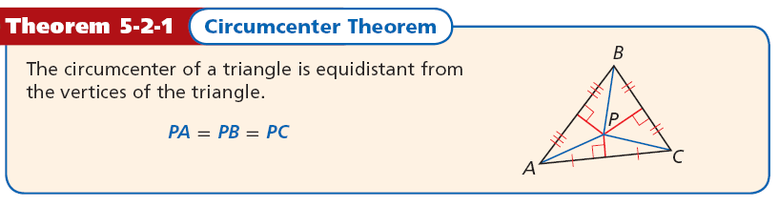

When three or more lines intersect at one point, the lines are said to be _______________________ The _________________________is the point where they intersect. In the construction, you saw that the three ***perpendicular bisectors of a triangle*** are concurrent. This point of concurrency is the ______________________.

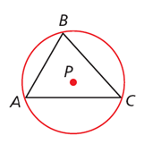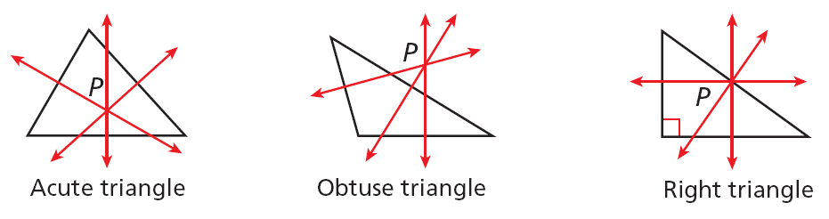The circumcenter can be inside the triangle, outside the triangle, or on the triangle.

The circumcenter of Δ*ABC* is the center of its circumscribed circle. A circle that contains all the vertices of a polygon is _________________ about the polygon.

|  |  |
| --- | --- |
| Example #1  *DG*, *EG*, and *FG* are the perpendicular bisectors of ∆ABC.  Find GC. | Example #2  Find GM.     Which measures given for the triangles are unnecessary? |
| Example #3  Find GK | Example #4  Find JZ |

A triangle has three angles, so it has three ***angle bisectors***. The angle bisectors of a triangle are also concurrent. This point of concurrency is the ______________________________.

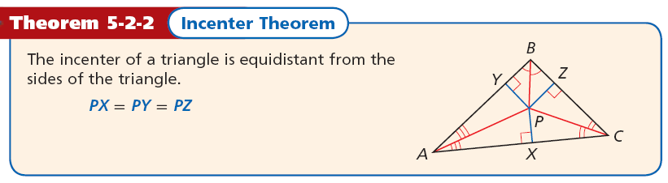

Unlike the circumcenter, the ***incenter is always inside the triangle****.*

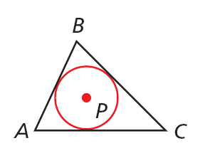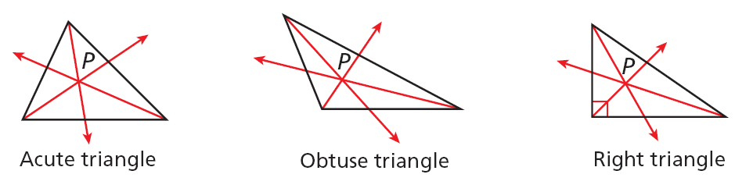

The _____________ is the center of the triangle’s *inscribed circle*. A circle ______________in a polygon intersects each line that contains a side of the polygon at exactly one point.

|  |  |
| --- | --- |
| Example 5  *MP* and *LP* are angle bisectors of ∆*LMN*. Find the **distance from *P* to *MN***. | Example 6  *MP* and *LP* are angle bisectors of ∆*LMN*. Find **m∠*PMN*.** |
| Example 7  *QX* and *RX* are angle bisectors of Δ*PQR*.  Find the **distance from *X* to *PQ*.** | Example 8  *QX* and *RX* are angle bisectors of ∆*PQR*. Find **m∠*PQX*.** |

How do you use the angle bisectors to find the indicated measures?

HW: P311, 3-6, 9-15,18-20, 22-27

|  |
| --- |
| **5.3 Medians of Triangles** |

**Learning Goals:** Students will apply properties of medians and altitudes of a triangle.

**Fun with Patty Paper**

1. Draw a large acute scalene triangle on your patty paper.
2. Locate the midpoint of each side of your triangle by placing one vertex on top of another and pinching in the middle.
3. To create a median, fold the paper so that the crease passes through a vertex and the midpoint of the opposite side. Construct all three medians. What do you observe? _______________________________________________________________________________________________________________________________________________________________________________________________________________  
   Do you think this will be true with Obtuse Triangles? ____________________________________________
4. Draw a large obtuse scalene triangle on your patty paper.
5. Locate the midpoint of each side of your triangle by placing one vertex on top of another and pinching in the middle.
6. To create a median, fold the paper so that the crease passes through a vertex and the midpoint of the opposite side. Construct all three medians. What do you observe? _______________________________________________________________________________________________________________________________________________________________________________________________________________

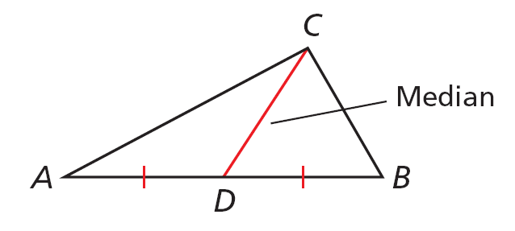A ____________________is a segment whose endpoints are a vertex of the triangle and the midpoint of the opposite side. Every triangle has three medians, and the medians are ____________________.

The point of concurrency of the **medians** of a triangle is the _________________. **The centroid is always inside the triangle.** The centroid is also called the *____________________* because it is the point where a triangular region will balance.

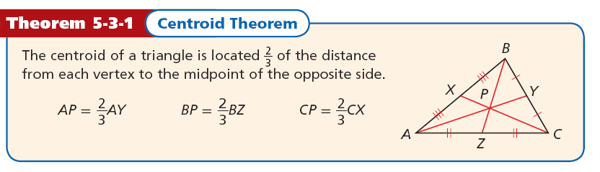

|  |  |
| --- | --- |
| Example 1A: In ∆*LMN*, *RL* = 21 and *SQ* =4 Find ***LS*.** | Example 1B  In ∆*LMN*, *RL* = 21 and *SQ* =4. Find ***NQ*.** |
| Example 1C In ∆*JKL*, *ZW* = 7, and *LX* = 8.1. Find **KW** | Example 1D In ∆*JKL*, *ZW* = 7, and *LX* = 8.1. Find **LZ**. |

What is the ratio of the segment lengths of each mean?

HW: P 317, 3-6, 12-15, 21-26, 29-32, 41-43

|  |
| --- |
| **5.4 The Triangle Midsegment Theorem** |

**Learning Goals:** Students will use properties of triangle midsegments.

A ____________________of a triangleis a segment that joins the midpoints of two sides of the triangle. Every triangle has _______ midsegments, which form the ***midsegment triangle***.

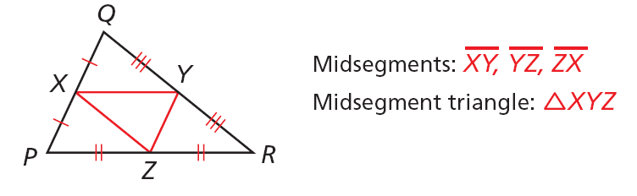

The following relationship is true for the three ______________of every triangle.

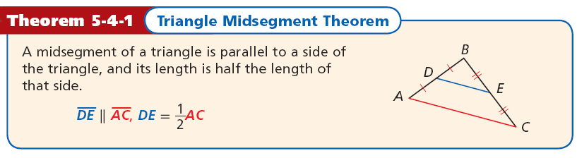

|  |  |
| --- | --- |
| Example 1A Find **BD**. | Example 1B Find **m∠*CBD.*** |
| Example 1C Find **JL.** | Example 1D Find **PM.** |
| Example 1E Find **m∠*MLK.*** | With a partner Make up your own example problem. |

To which side of the triangle is a midsegment parallel?

HW: 324: 3-9, 11-27, 30-35

|  |
| --- |
| **5.7 Pythagorean Theorem** |

**Learning Goal**: Students will use the Pythagorean Theorem and its converse to solve problems and to classify triangles.

The Pythagorean Theorem is probably the most famous mathematical relationship. As you learned in Lesson 1-6, it states that in a right triangle, the sum of the squares of the lengths of the legs equals the square of the length of the hypotenuse.

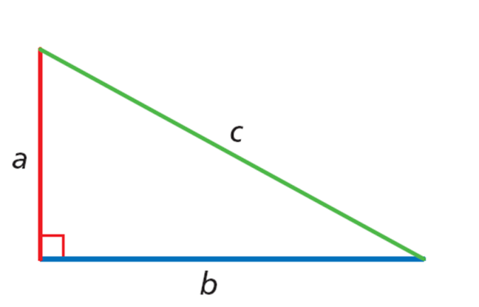

***a*2 + *b*2 = *c*2**

|  |  |
| --- | --- |
| Example #1  Find the value of x. Give your answer in simplest radical form. | Example #2  Find the value of x. Give your answer in simplest radical form. |
| Example #3  Find the value of x. Give your answer in simplest radical form. | Example #4    Find the value of x. Give your answer in simplest radical form. |

Example #2

|  |  |
| --- | --- |
| **Randy is building a rectangular picture frame. He wants the ratio of the length to the width to be 3:1 and the diagonal to be 12 centimeters. How wide should the frame be? Round to the nearest tenth of a centimeter.** | **What if...? According to the recommended safety ratio of 4:1, how high will a 30-foot ladder reach when placed against a wall? Round to the nearest inch.** |

A set of three nonzero whole numbers *a*, *b*, and *c* such that *a*2 + *b*2 = *c*2 is called a __________________________..

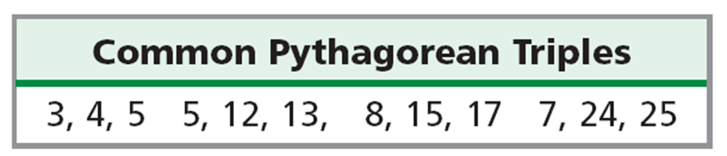

Example #3: **Find the missing side length. Tell if the side lengths form a Pythagorean triple. Explain.**

|  |  |
| --- | --- |
|  |  |
|  |  |
|  |  |

The converse of the Pythagorean Theorem gives you a way to tell if a triangle is a right triangle when you know the side lengths.

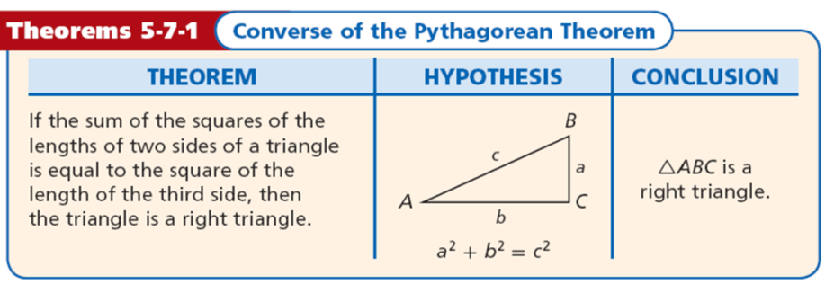

You can also use side lengths to classify a triangle as acute or obtuse.

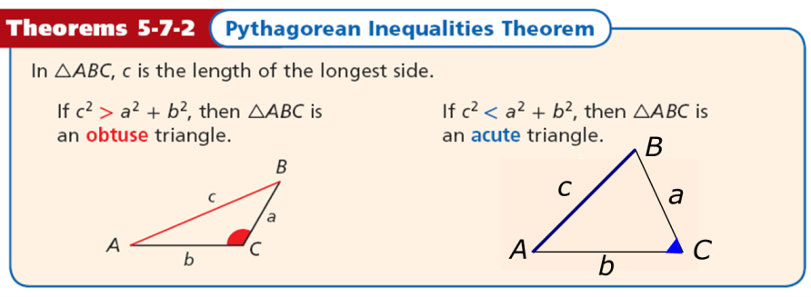

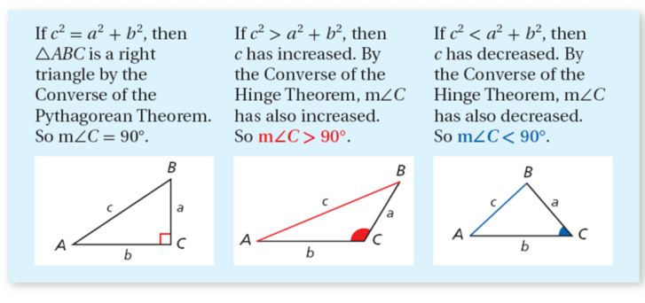

Example #4: **Tell if the measures can be the side lengths of a triangle. If so, classify the triangle as acute, obtuse, or right.**

|  |  |
| --- | --- |
| 5, 7, 10 | 5, 8, 17 |
| 7, 12, 16 | 11, 18, 34 |
| 3.8, 4.1, 5.2 |  |

HW: P352: 2-29

|  |
| --- |
| 5.8 Special Right Triangles |

**Learning Goal**: Students will justify and apply properties of 45°-45°-90° and 30°- 60°- 90° triangles.

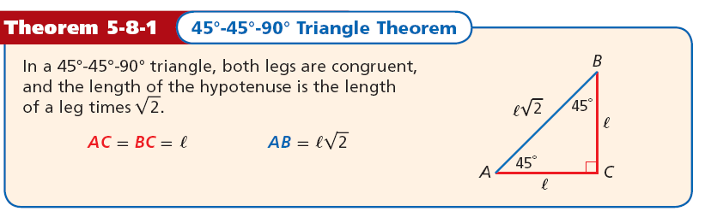

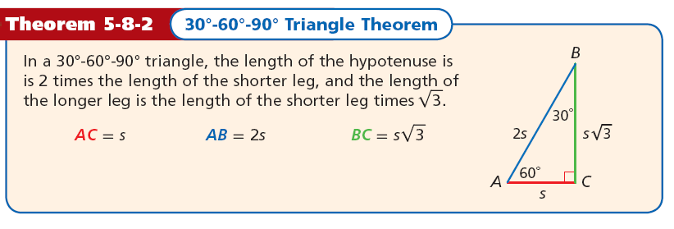

|  |  |
| --- | --- |
| Example#1: Find the value of x. Give your answer in simplest radical form. | Example #2: Find the value of x. Give your answer in simplest radical form. |
|  |  |

Example #3

|  |  |
| --- | --- |
|  |  |
|  |  |
|  |  |

Example #4

|  |  |
| --- | --- |
| **An ornamental pin is in the shape of an equilateral triangle. The length of each side is 6 centimeters. Josh will attach the fastener to the back along *AB*. Will the fastener fit if it is 4 centimeters long?** | **Jana is cutting a square of material for a tablecloth. The table’s diagonal is 36 inches. She wants the diagonal of the tablecloth to be an extra 10 inches so it will hang over the edges of the table. What size square should Jana cut to make the tablecloth? Round to the nearest inch.** |
| Tessa’s other dog is wearing a square bandana with a side length of 42 cm. What would you expect the circumference of the other dog’s neck to be? Round to the nearest centimeter. | A manufacturer wants to make a larger clock with a height of 30 centimeters. What is the length of each side of the frame? Round to the nearest tenth. |

HW: Page 1-21