|  |
| --- |
| Skill Review – Simplifying Radicals |

**Learning Goals**: Students will be able to add, subtract, multiply and square radicals with answers being exact and approximate.

A ***Perfect Square*** is: ____________________________________________________

__________________________________________________________________________________________________________________________________________________________________________________________________________________

An expression containing square roots is in simplest form when:

* The radicand has no perfect square factors other than one
* The radicand has no fractions
* There are no square roots in the denominator

Simplifying a Radicals:

|  |  |
| --- | --- |
|  |  |

Example 1

A) B)  C)  D) 

Adding and Subtracting Radicals:

|  |  |
| --- | --- |
| **Same Radical: + or – the Coefficients  Simplify:** | **Different Radical: Simplify the Radicals first. If same then see the box at left, If different:  Simplify:** |

|  |  |  |
| --- | --- | --- |
| Multiplying Radicals   |  | | --- | |  | | Dividing Radicals |

HW: WorkSheet

|  |
| --- |
| 5.7 Pythagoren Theorem |

**Learning Goals:** Students will use the Pythagorean Theorem and its converse to solve problems and classify triangles.

The Pythagorean Theorem is probably the most famous mathematical relationship. As you learned in Lesson 1-6, it states that in a right triangle, the sum of the squares of the lengths of the legs equals the square of the length of the hypotenuse.

***a*2 + *b*2 = *c*2**

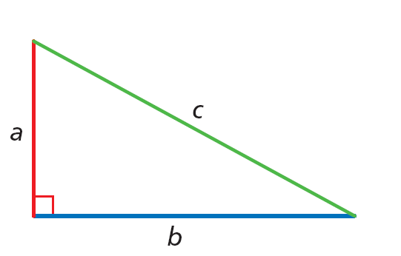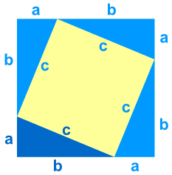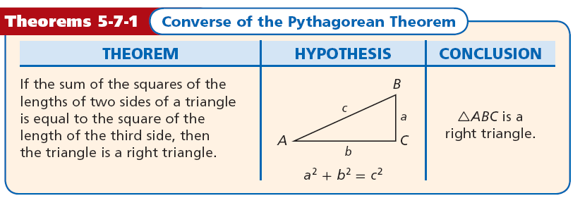

|  |  |
| --- | --- |
| Example #1: Find X | Example #2: Find X and All Side Lenghts: |

A set of three nonzero whole numbers a, b, and c such that a2 + b2 = c2 is called a Pythagorean triple.

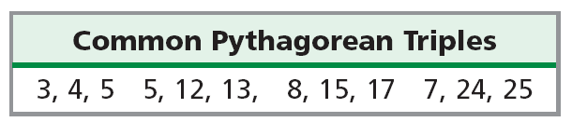

|  |  |
| --- | --- |
| Example #3: Find the missing side length. Tell if the side lengths form a Pythagorean triple. Explain. | Example #4: Find the missing side length. Tell if the side lengths form a Pythagorean triple. Explain. |

HW: WorksheetExample #5: According to the recommended safety ratio of 4:1, how high will a 30-foot ladder reach when placed against a wall? Round to the nearest inch.

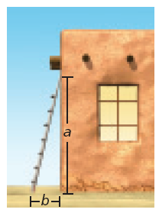

Example #6: Randy is building a rectangular picture frame. He wants the ratio of the length to the width to be 3:1 and the diagonal to be 12 centimeters. How wide should the frame be? Round to the nearest tenth of a centimeter.

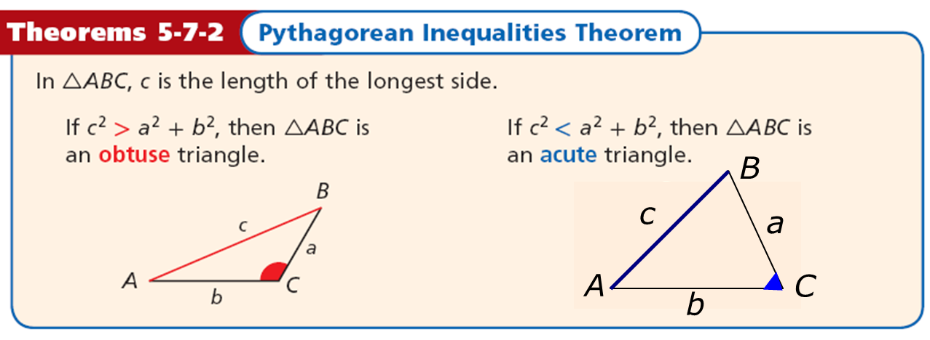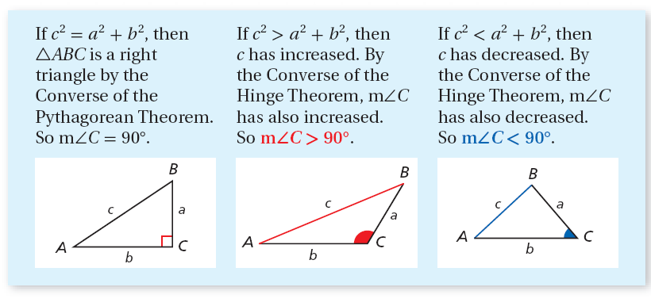

Example #7: Tell if the measures can be the side lengths of a triangle. If so, classify the triangle as acute, obtuse, or right. 5, 7, 10

Example #8: Tell if the measures can be the side lengths of a triangle. If so, classify the triangle as acute, obtuse, or right. 5, 8, 17

Example #9: Tell if the measures can be the side lengths of a triangle. If so, classify the triangle as acute, obtuse, or right. 7, 12, 16

|  |
| --- |
| 5.8 Special Right Triangles |

**Learning Goal**: Students will justify and apply properties of 45°-45°-90° and 30°- 60°- 90° triangles.

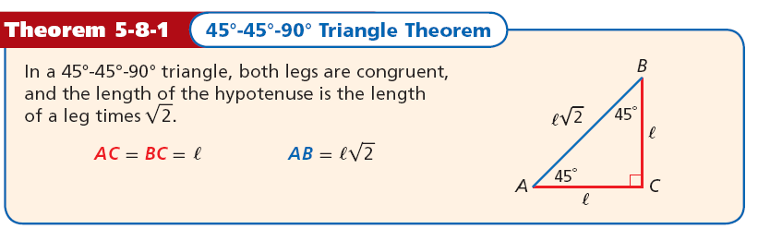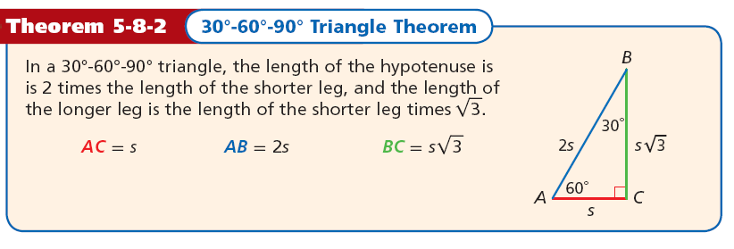

|  |  |
| --- | --- |
| Example#1: Find the value of x. Give your answer in simplest radical form. | Example #2: Find the value of x. Give your answer in simplest radical form. |

Find the value of x. Give your answer in simplest radical form.

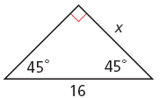

|  |  |
| --- | --- |
| Example #3 Find the values of x and y. Give your answer in simplest radical form. | Example #4 Find the values of x and y. Give your answer in simplest radical form. |
| Example #5 Find the values of x and y. Give your answer in simplest radical form. | Example #6 Find the values of x and y. Give your answer in simplest radical form. |

HW: Page 360: 9-21

|  |
| --- |
| 8.2 Trigonometric Ratios  Objectives: |

**Learning Goal**: Students will find the sine, cosine, and tangent of an acute angle, and find side lengths in right triangles to solve real-world problems.

**_________________________** is a ratio of two sides of a right triangle.

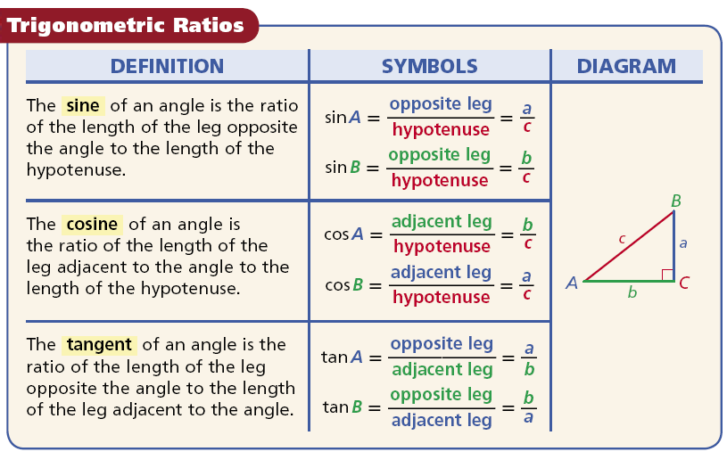

**Hypotenuse**- Always opposite the right angle

**Opposite side**- Across from the angle involved in the calculation

**Adjacent side**- non hypotenuse side forming the angle used in the calculation

Label the Triangle:

Example #1: Write the trigonometric ratio as a fraction and as a decimal rounded to the nearest hundredth.

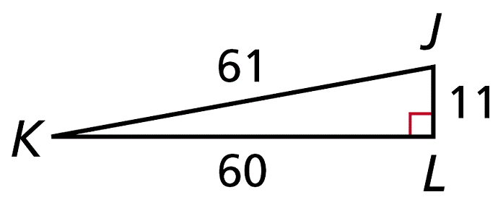

sin J

tan K

cos K

Example#2: Write the trigonometric ratio as a fraction and as a decimal rounded to the nearest hundredth.

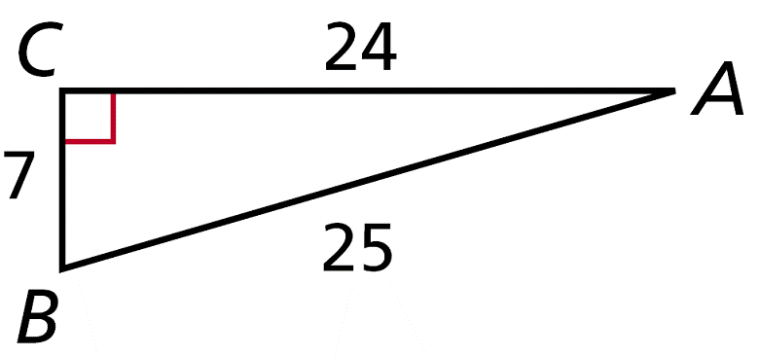

cos A

tan B

sin B

Example #3: Find the Given Trig Ratio.

|  |  |
| --- | --- |
| sin 30  cos 60  tan 30  tan 60  cos 30  sin 60 | Sin 45  Cos 45  Tan 45 |

Example #4: Use your calculator to find the trigonometric ratio. Round to the nearest hundredth.

cos 19° tan 11°

sin 88°

Example #5:

|  |  |
| --- | --- |
| Find the length of BC. | Find the length of QR |

Example #6:   
The Pilatusbahn in Switzerland is the world’s steepest cog railway. Its steepest section makes an angle of about 25.6º with the horizontal and rises about 0.9 km. To the nearest hundredth of a kilometer, how long is this section of the railway track?

HW: Page 529: 22-48Even, 49-50

|  |
| --- |
| 8.3 Solving Right Triangles |

**Learning Goal**: Students will use trigonometric ratios to find angle measures in right triangles and solve real-world problems.

***Inverse trig functions*** are used when we are trying to find the measurement of an angle.

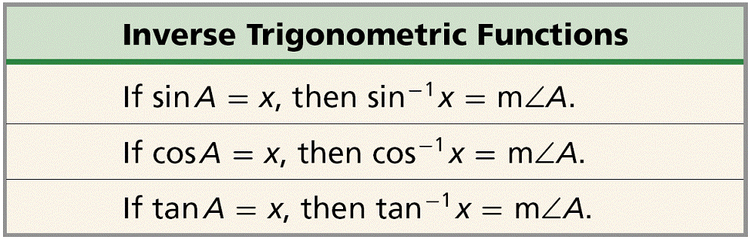

Use your calculator to find each angle measure to the nearest degree.

1a**.** cos-1(0.87)

1c. tan-1(0.71)

1b. sin-1(0.85)

Find the unknown measures. Round the side lengths to the nearest hundredth and angle measures to the nearest degree.

Example 2

|  |  |
| --- | --- |
| Find | Find x. |

Find X



***The steepness of a road is often expressed as a percent grade. For example, a road with a grade of 6% actually raises 6 ft for every 100 ft it travels horizontally.*** 

A highway sign warns that a section of road ahead has a 7% grade. To the nearest degree, what angle does the road make with a horizontal line?

Baldwin St. in Dunedin, New Zealand, is the steepest street in the world. It has a grade of 38%. To the nearest degree, what angle does Baldwin St. make with a horizontal line?

HW: Page: 538: 21-35, 38-44

|  |
| --- |
| 8.4 Angle of Elevation and Depression  Objectives |

**Learning Goal**: Students will solve problems involving angles of elevation and depression.

An **_______________________** is the angle formed by a horizontal line and a line of sight to a point *above* the line. In the diagram, ∠1 is the angle of elevation from the tower *T* to the plane *P*.

An **_____________________** is the angle formed by a horizontal line and a line of sight to a point *below* the line. ∠2 is the angle of depression from the plane to the tower.

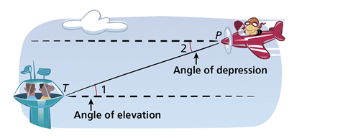

Ex. 1

The Seattle Space Needle casts a 67-meter shadow. If the angle of elevation from the tip of the shadow to the top of the Space Needle is 70º, how tall is the Space Needle? Round to the nearest meter.

Ex. 2

Suppose the plane is at an altitude of 3500 ft and the angle of elevation from the airport to the plane is 29°. What is the horizontal distance between the plane and the airport? Round to the nearest foot.

Ex. 3

An ice climber stands at the edge of a crevasse that is 115 ft wide. The angle of depression from the edge where she stands to the bottom of the opposite side is 52º. How deep is the crevasse at this point? Round to the nearest foot.

Ex. 4

Ms. Blay is 67” tall. At 3:00 in the afternoon, she notices her shadow is 80”. Curious…, she wants to know the angle of elevation of the sun. Can you help her?

HW: Page 547: 10-22

|  |
| --- |
| 8.5 The Law of Sines and The Law of Cosines  Objectives |

**Learning Goal**: Students will use the Law of Sines and the Law of Cosines to solve any triangle.

In 8.5 we learn to solve ANY Triangle (all triangles are NOT right triangles)

Some triangles have OBTUSE angles.

Use a calculator to find each trigonometric ratio. Round to the nearest hundredth.

1**a. tan 175° 1b. cos 92° 1c. sin 160°**

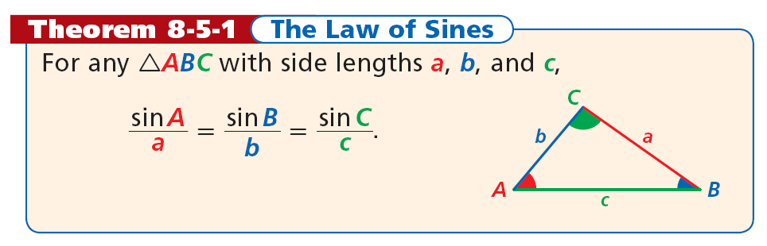

You can use the Law of Sines to solve a triangle if you are given:

• two angle measures and any side length (ASA or AAS)

or

• two side lengths and a non-included angle measure (SSA).

**Example 2: Find all the measures. Round lengths to the nearest tenth and angle measures to the nearest degree.**

|  |  |
| --- | --- |
| ***Find NP*** | ***Find m∠L*** |
| ***Find AC*** |  |
| ***Homework: P555, 1-9, 10-12*** |  |

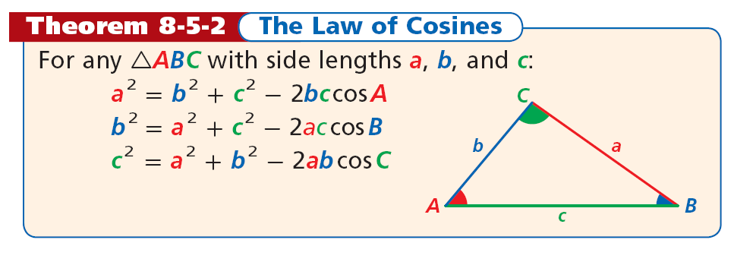

You can use the Law of Cosines to solve a triangle if you are given

• two side lengths and the included angle measure (SAS) or

• three side lengths (SSS).

**Find the measure. Round lengths to the nearest tenth and angle measures to the nearest degree.**

|  |  |
| --- | --- |
| **Find DE** | ***Find m∠K*** |

Homework: Page 555, 17-25, 13-15